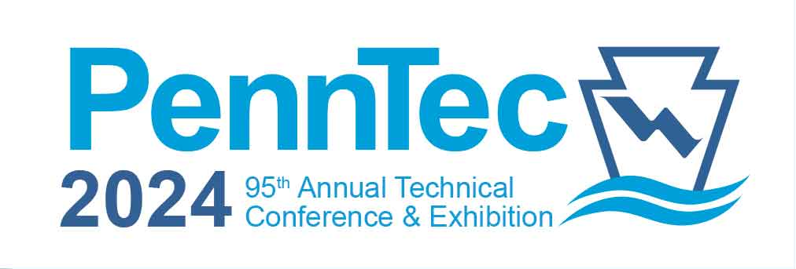

Call for Technical Presentations and Case Studies

**Pennsylvania Water Environment Association’s Annual Technical Conference**

**June 16-19, 2024 ~ Penn Stater Hotel & Conference Center ~ State College, PA**

**Instructions for Submitting a Technical Presentation or Case Study**

Individuals desiring to present at **PWEA’s** PennTec Conference should ***submit a presentation/case study by no later than Friday, September 29, 2023.***Please read the criteria below to be sure your submission contains the most relevant information. Presentations will be in blocks of 30 minutes, which includes time for questions and answers. **Presentations/Case Studies will be accepted only by email and in WORD format. Send completed presentation/case study to:** [**presentations@pwea.org**](mailto:presentations@pwea.org)**.** There is no limit to the number of presentations/case studies that may be submitted by an individual or organization. However, in order to provide a valuable educational experience for attendees, the Program Committee will work to limit the number of presentations by a single individual or organization within a technical program. **Membership in PWEA is not a requirement to present.** **Presenters are responsible for all of their own transportation, lodging and travel related expenses.** *Discounted registration fees will be offered to the Primary Presenter for the day of presentation, or for the entire conference*. (Any additional presenters must register at the regular conference rates.) Only the Primary Presenter for a technical session will be published in the PennTec ConferenceRegistration Brochure.

Presentations are being solicited on cutting-edge and hot topics for **Wastewater,** **Stormwater** and/or **Drinking Water** in the following categories. ***The main bullets are the Technical Program categories, indicating the focus for each program. The sub-bullets are suggestions for topics in each discipline. Other topics not included on this list are welcome. Use the Technical Program categories to identify where your presentation/case study would best fit when completing the Submission Form.***

|  |  |
| --- | --- |
| * **Biosolids**   + Innovative usage   + WWTP Case Studies   + Emerging Technologies   + Dewatering   + Disposal * **Collection Systems**    + Inflow & infiltration   + Private property issues   + Flow issues related to climate change   + Pump station topics   + Force main topics   + Measurement – tv – laser – sonar   + Smart or intelligent system management   + Pipe or lateral rehab   + Other relevant issues * **Engineering (Water / Wastewater)**   + New techniques and equipment for underground utility verification/location   + Improvements related to drinking water or wastewater safety   + Mitigation of disinfection byproducts   + Treatment Design Innovations * **Construction (Water / Wastewater)**   + Alternative Project Delivery methods   + Use of Design-Build for project delivery   + New/innovative construction techniques   + Constructability reviews for Design projects   + Resiliency | * **Government/Regulatory Affairs (Water / Wastewater)**   + Complying with regulatory requirements   + Case studies about regulatory agency and regulated entity cooperation   + Needed regulatory program changes   + Impact of legislation and/or regulations on facility operations and budgets * **Industrial Waste Pretreatment**   + PFOS / PFAS   + Innovative Design * Municipal Industrial Pretreatment Program Tasks   + Emerging Contaminants   + Water Source Protection   + Developing and complying with EPA mandated Industrial Pretreatment Programs * **Laboratory Practices (Water / Wastewater)**   + Catalysts and Reagents   + Ethics   + Equipment   + Innovative Techniques & Methods   + Data Management * **Professional Operations (Water / Wastewater)**   + Ethics/Best Practices   + Innovation   + Preventative Maintenance   + NPDES Permit renewals, inspections and/or compliance   + PA One Call   + Mapping/GIS integration   + System Optimization   + Smart Development/System Growth Practices   + Crisis/Emergency Management |
| * **Safety (Water / Wastewater)**   + OSHA Updates and Practices   + Employee Safety – office, plant and field   + Pandemic safety lessons learned * **Stormwater**   + Regional approach to stormwater management   + Integrated water resource planning   + Ramping up a stormwater authority   + Water quality at the watershed scale   + GIS tools for planning and asset management   + Stormwater BMPs – Case studies of funding, performance, and maintenance * Urban climate resilience * Impact of the *new normal* for weather patterns * Updating codes and ordinances for better stormwater management * Municipal collaboration for meeting MS4 requirements * Model programs for MS4 public education and involvement * Innovative and cost-effective approaches to community stormwater problems * Model programs for flood management * Stormwater rate making * **Soft Skills**    + Time Management   + Effective Communication/Conflict Resolution   + Adaptability and Work Ethic   + Proactive/Critical Thinking / Decision Making | * **Utility Management (Water / Wastewater)**   + Leadership Development and Organic Growth for Sustainable Management   + Working effectively with neighboring utilities and municipalities; Community Outreach and meeting consumer demands with a focus on system sustainability   + Effective Customer Service   + Using Technology to Enhance Productivity   + Setting rates based on sound operational and financial planning   + Budgeting focused on critical activities for sustained performance   + Inter-Agency cooperation: Meeting service expectations and regulatory requirements   + Levels of Service: Improving responses to emergencies and the security and safety of assets   + Prolonging asset life and improving decisions about asset rehabilitation, repair, and replacement   + Asset Management/Business Case Evaluation/Capital Program Optimization: Reducing overall costs for both operations and capital expenditures   + GIS System Integration   + SCADA Systems * **Privatization & Regionalization (Water / Wastewater)** * Case studies of privatization * Analysis of offers to take a municipal system private * Infrastructure changes (improvements or other) after privatization * Political implications and case studies * Case Studies of smaller systems combining – Regionalization * Experience with Municipal Authorities – Wastewater Collection and/or Stormwater |

SUBMISSION FORMAT REQUIREMENTS

Presentations/case studies must be submitted in **Word format** using the Submittal Form within this document. It can also be found on PWEA’s website at: <https://www.pwea.org/annual_technical_conference.php>. **Presentations/case studies should be a minimum of one and a maximum of three double-spaced full pages of text, including bibliography**. Up to three additional pages of supporting tables and graphics may be included. The footer of each page should contain the corresponding author’s last name, presentation/case study title, and the page number (example: Smith, Regional Approach to XYZ, page 1 of 3). **Presentations/case studies that fail to meet the maximum page requirement will be given consideration after other submissions**. Submission must clearly define the objectives, status, methodology, findings, and significance of the investigation or study. Submissions on hot topics, regulatory issues, and new technologies are especially welcome. **The Primary Presenter indicated on the Submittal Form will be notified of acceptance or rejection by December 29, 2023.**

CRITERIA FOR PRESENTATION / CASE STUDY SELECTION

1. **RELEVANCE**: The topic presented in the presentation / case study should appeal to the Conference audience; presenting breakthrough technologies, new concepts, novel applications of concepts, original ideas, new twists, hot topics, or application of fundamental techniques to today’s problems. The presentation / case study should present ideas, concepts or lessons learned that are transferable and usable at other facilities and situations.
2. **STATUS OF PROJECT**: The presentation / case study should establish that the project or case study is well-developed and should present data or results to support the hypothesis or principle being demonstrated. Data should have been subjected, at a minimum, to preliminary analysis. Presentations showing concrete results with practical applications are more likely to be accepted.
3. **TECHNICAL CONTENT**: The objectives and scope of the project should be stated. The conditions under which the data were obtained and the general procedures/methodology used should be presented. The presentation should address the consequences of the issue/project presented. The consequences, both intended and unintended, could include environmental, economic, and social impacts.
4. **BENEFITS AND SIGNIFICANCE**: Actual benefits and applications should be reported. Has the project helped to clean water or has it reduced pollutant discharges? Does the method described save time or money or increase accuracy? Is system management or operations more efficient or effective? Is this a specific finding or of more general application?
5. **CONTENT, CLARITY, AND QUALITY**: Presenters should prepare clear, concise presentations / case studies that follow the requirements. The quality and content of the presentation / case study is considered indicative of the final technical presentation for **PennTec 2024.**

Page 2 of 4

**

Presentation / Case Study Submittal Form

2024 PWEA Annual Technical Conference & Exhibition – PennTec 2024

**June 16-19, 2024 ~ Penn Stater Hotel & Conference Center ~ State College, PA**

**SUBMISSION DEADLINE: Friday, September 29, 2023**

Save completed, unprotected form in WORD **to your computer and email it to** [**presentations@pwea.org**](mailto:presentations@pwea.org)**.**

**1. Type of Presentation/Case Study Submission: ❑** Single Presentation (approx. 30 minutes)

**❑** Full or Half Day DEP-Approved Course

**❑** **Wastewater related** **❑ Stormwater related** **❑** **Drinking water related**

**2. Session Title: ________________________________________________________________________**

**_____________________________________________________________________________________**

**3. 1st Choice Technical Program Category: __________________________________________________**

Use the **Technical Program Categories** Listed on the “**Instructions for Submitting**” Document; **NOT** the Sub-Categories.

**2nd Choice Technical Program Category: __________________________________________________**

Use the **Technical Program Categories** Listed on the “**Instructions for Submitting**” Document; **NOT** the Sub-Categories.

**4. Primary Presenter** (***all conference-related correspondence will be directed to this individual***)**:**

|  |  |
| --- | --- |
| Name: | *(include any credentials you wish to have printed in the program; i.e., PE, PhD, LO, etc.)* |
| Organization: |  |
| Address: |  |
| City/State/Zip: |  |
| Phone: |  |
| Email: |  |

**5. Will this or a similar paper or session be published or presented before June 18, 2023?**

**❑** No  **❑** Yes **If yes, where: ______________________________________________**

**6. Completion date of this work/project/program: ________________________________**

**7. Short description of proposed presentation – Limit text to 50 words or less.**

Should your topic be selected for presentation at the **PennTec Conference**, the description you provide here (**limited to 50 words**) will be published in the Registration Brochure and the Onsite Conference Program.

*Insert text here:*

Page 3 of 4

**FULL DESCRIPTION OF PRESENTATION/CASE STUDY**

Page 4 of 4