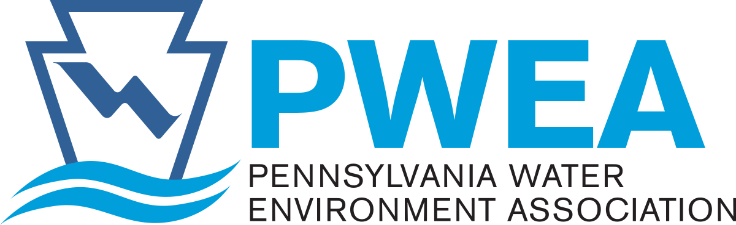
MEMBER:

Water Environment Federation

Official Publication:
Keystone Water Quality Manager
ADMINISTRATIVE OFFICE:
PO Box 3367
Gettysburg, PA 17325
Phone: 717-642-9500
Fax: 717-303-5219
E-mail: pwea@pwea.org
www.pwea.org

Pennsylvania Water Environment Association

TO: PWEA Members, Environmental Engineering and Science Faculty and Students

FROM: PWEA Research Committee
Holly T. Frederick, Ph.D., P.E, BCEE. – Committee Chair

SUBJECT: CALL FOR ABSTRACTS, RESEARCH SESSION

The 2023 Annual Conference of the Pennsylvania Water Environment Association (PWEA) will be held at the Hershey Lodge in Hershey, PA from June 18-21, 2023. The Research Session on Tuesday, June 20, is devoted to undergraduate and graduate student research. Its intent is to provide a showcase for ongoing research activities in the fields of wastewater, water quality, and environmental management relevant to Pennsylvania. Suggested topics include (but are not limited to): wastewater treatment; sludge/biosolids management; beneficial reuse; bioenergy production from wastewater; agricultural runoff; stormwater treatment; watershed management; groundwater remediation; and industrial wastewater treatment.

Abstract preparation: Students are encouraged to work with their faculty advisors to submit a short abstract, along with the identification information requested on the following page by January 13, 2023. Abstracts must be kept to 300 words and may include up to two figures or tables. Abstracts will be evaluated by the Research Committee on the basis of overall quality, technical content, originality, adherence to the guidelines, and relevance to issues related to water treatment, water quality, and environmental management in Pennsylvania. Student authors can request consideration for a poster only, oral platform presentation only, or both presentation options. The student authors of all qualifying abstracts will be invited to present posters at the conference, and the authors of the top five abstracts will be invited to give oral presentations, with the option to also display a poster.

Research session & poster contest: At the conference, posters will be judged by faculty and practicing engineers, and outstanding posters will receive awards (based on the quality of their presentations). The top undergraduate and graduate poster presenters will receive a Student Research Poster Award certificate. In addition, each of the five oral presenters will be receive a Student Research Platform Award certificate and abstract publication in the Keystone Water Quality Manager. (Conference registration and lunch are free for all student presenters.)

Deadlines: The deadline for submission of abstracts is January 13, 2023. Students will be notified in February if their abstract is accepted, and information regarding preparation of poster and platform presentations will be forwarded at that time.

Formatting & submission instructions: Use the instructions and example template on the following page to format your abstract (a separate cover page is not required). Submit an electronic copy of the abstract (as a single Word document) to Dr. Holly Frederick (holly.frederick@wilkes.edu) by January 13, 2023.

Formatting Instructions for Abstract Submission to the PennTec 2023 Research Session

Header: Bold and center the header, and indicate if the authors wish to be considered for a poster presentation only (POSTER), oral presentation (PLATFORM), or either (POSTER/PLATFORM), followed by the words “ABSTRACT: PennTec 2023 Research Session”.

Title: Bold and center the title and use the Chicago style for title capitalization (i.e., capitilize the first word of the title, the last word of the title, and all principal words (nouns, verbs, etc.), but not prepositions).

Authors: Provide a complete list of all authors by first and last names in a continuous, bolded line; identify the presenting student with an asterisk (*) superscript after their last name and all authors with numerical superscripts after their last names.

Author titles and affiliations: For each author on a separate line, list their title and institution following the number provided in the superscript after their last name.

Email addresses: List the email addresses of the presenting student and faculty advisor (as a single line).

Example template:

POSTER/PLATFORM: 2023 PennTec Conference Research Session

Title of Abstract

Jane Student^{*1}; John Engineer²; Super Advisor³
¹Undergraduate, Wilkes University, Environmental Engineering and Earth Sciences Department, Wilkes-Barre, PA 18766
²Senior Engineer, Environmental Consultants, State College, PA 16803
³Associate Professor, The Pennsylvania State University, Dept. of Civil and Environmental Engineering, University Park, PA 16802
*Presenting author: janestudent@wilkes.edu; Faculty advisor: superadvisor@psu.edu

Abstract: Abstracts are limited to 300 words and may also include up to two figures or tables. Please use Arial 11 point font, 1.15 spacing, 1” margins, left justification, with a single space between paragraphs. Figures and tables should be referred to by number (i.e., Figure 1, Table 1) within the abstract and be labeled with a fully descriptive title (note that figure captions should be placed beneath figures; whereas table titles should be placed above tables). The font used in figures and tables should match that of the body of the text, if possible. Figures should be reproducible in black and white without any loss in information (i.e., ensure that line/symbol colors have significant contrast in black and white and are easily distinguishable). Numerical values should be provided in metric units.

