DISCLAIMER NOTICE

This example Employee Safety Manual is provided by the Pennsylvania Water Environment Association as a service to our members. The information in this manual is generic and for example purposes only. Every workplace has unique safety hazards and every employer has rules and regulations specific to the workplace and its hazards. This example Employee Safety Manual is not intended as a substitute for carefully developed, site-specific policies and procedures.

This example Employee Safety Manual is intended as a guide and to foster consideration of the many important aspects of a comprehensive workplace safety program. Each element of the example Employee Safety Manual may be modified, expanded, or deleted as appropriate by the employer. Information included in this example manual may be inappropriate for a particular workplace. It is the responsibility of the employer to carefully review all of the information and decide what is appropriate and what is not. Other important safety policies or procedures that might be necessary for a particular workplace may not appear in this example Employee Safety Manual. It is not the intent of the PWEA that this document be used as written, and the PWEA advises the user that any such use could result in inappropriate or inadequate safety policies or procedures.

By the provision of this document the Pennsylvania Water Environment Association does not represent that it has any special knowledge or experience with regard to the matters discussed in the document, or that it is advising anyone as to the proper safety policies and procedures appropriate for any workplace. This document may contain typographical errors, errors of fact, or errors of law, for which the PWEA is not responsible. Before implementing a safety program, users are advised to consult with qualified experts in the field.

The provision of this example Employee Safety Manual is made without consideration and does not create a contract or obligation of any kind by the Pennsylvania Water Environment Association with respect to the user. The PWEA does not indemnify any user for any loss, injury, or property damage that may result as a result of reliance on the information in this document, nor does the PWEA represent that the information in this document is accurate, appropriate, or adequate for any use.

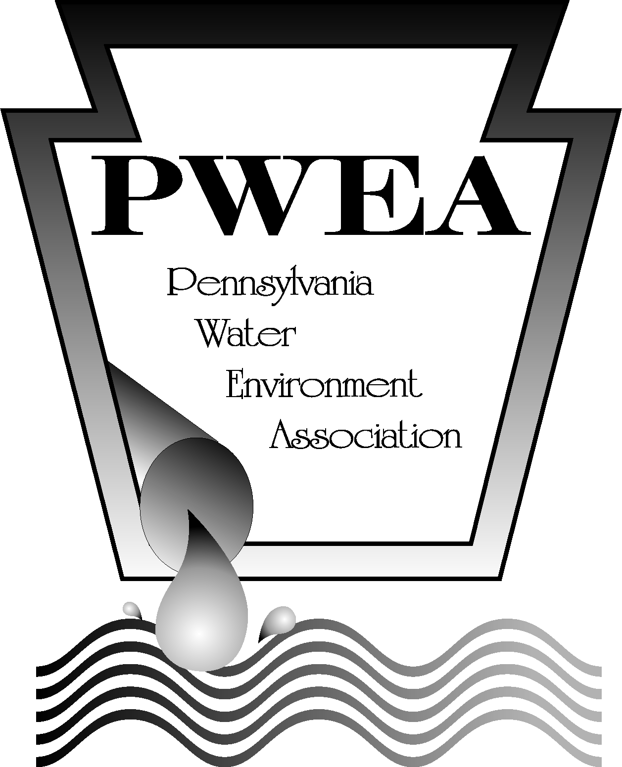

SAFETY FIRST AUTHORITY
HEALTH & SAFETY MANUAL
TABLE OF CONTENTS

ITEM | SECTION | PAGE
SAFETY MANUAL RECEIPT |  | i.
INTRODUCTION |  | ii
STATEMENT OF WORKPLACE SAFETY |  | iii
WORKPLACE SAFETY COMMITTEE BYLAWS |  | iv
SAFETY POLICY |  | v
GENERAL SAFETY RULES |  | vi
SAFETY ORIENTATION & TRAINING |  | vii
BLEACH LIQUOR | MANUAL | 1
CALCIUM HYDROXIDE | MANUAL | 2
CHLORINE | MANUAL | 3
ELECTRICAL EQUIPMENT | MANUAL | 5
FIRST AID & MEDICAL SERVICE SAFETY RULES | MANUAL | 7
LADDER SAFETY RULES | MANUAL | 8
LIFTING & BODY MECHANICS TECHNIQUE | MANUAL | 10
OFFICE SAFETY RULES | MANUAL | 11
OXYGEN DEFICIENCY | MANUAL | 12
PERSONAL HYGIENE | MANUAL | 13
PORTABLE FIRE EXTINGUISHERS | MANUAL | 14
SAFETY EQUIPMENT RULES | MANUAL | 16
SAFETY SIGNS | MANUAL | 17
CHEMICAL STORAGE & SAFETY | POLICY | 18
EVACUATION PLAN | POLICY | 21
EYE PROTECTION | POLICY | 25
REQUEST FOR PRESCRIPTION SAFETY EYEWEAR | FORM | 28
FOOT PROTECTION | POLICY | 29
REQUEST FOR SAFETY SHOE REIMBURSEMENT | FORM | 30
HEAD PROTECTION | POLICY | 31
HEARING PROTECTION | POLICY | 34
HOTWORK | POLICY | 36
MOTOR VEHICLE OPERATION | POLICY | 37
NOMEX CLOTHING | POLICY | 38
PORTABLE TOOLS & EQUIPMENT | POLICY | 40
RESPIRATORY PROTECTION | POLICY | 42
RIGHT TO KNOW | POLICY | 45
SEAT BELT | POLICY | 49
SHORING | POLICY | 50
SKIN PROTECTION | POLICY | 54
SMOKING | POLICY | 55
ACCIDENT INVESTIGATION | PROCEDURE | 56
ACCIDENT/NEAR MISS REPORT | REPORT/FORM | 58
CONFINED SPACE | PROCEDURE | 60
LOCK-OUT TAG-OUT | PROCEDURE | 69
MATERIAL HANDLING & STORAGE | PROCEDURE | 78
USE OF SCBA FOR ON –CALL TRUCKS | PROCEDURE | 79
VEHICLE ACCIDENT | PROCEDURE | 80
RESOURCES |  | 81

SAFETY MANUAL RECEIPT

This handbook is being provided to you in order to help you work safely. This manual does not assume that every normally accepted safety procedure is included nor that any abnormal or unusual condition may not warrant or require further or additional procedures. Any deficiencies in this manual or other safety procedures that should be included should be brought to the attention of your supervisor or a representative of the safety committee.

The Safety First Authority is making every effort to create safe working conditions and desires that you help in preventing accidents by following these basic safety instructions.

Please acknowledge receipt of this manual by placing your signature and the date you received the manual on the lines below.

___________________________________________
Employee Signature

___________________________________________
Date

(MUST BE RETURNED TO PERSONNEL OFFICE FOR PERMANENT RECORD FILE)

Safety Manual Receipt Page 1 of 1

INTRODUCTION

Safety First Authority Employee:

This handbook is provided to help you work safely. It does not assume that every normally accepted safety procedure is included or that any abnormal or unusual condition may not require additional procedures.

Safety First Authority makes every reasonable effort to create safe working conditions. Your help in preventing accidents by following these basic safety instructions is necessary.

You are reminded that failure to observe all safety rules and policies is subject to disciplinary action up to and including discharge.

Management is committed to reviewing its policies continually. Accordingly, the policies outlined in this handbook are subject to review and change by management at any time. In the event that statements by supervisors are inconsistent with Authority policies, the policies shall govern.

Management

Introduction Page 1 of 1

SAFETY FIRST AUTHORITY
STATEMENT OF WORKPLACE SAFETY

It is the policy of the Safety First Authority to provide an active workplace Safety & Health Program. The objective of the program is to ensure a safe environment for all employees and visitors as well as to protect Authority buildings, equipment, and other property.

A safety committee has been implemented to help attain these goals. Some of the “tools” used by the committee shall include, but are not be limited to:

- Performing safety inspections of Authority buildings and grounds.
- Reviewing accident report and accident investigation forms.
- Promoting safety awareness throughout the Authority.
- Implementing required safety programs as mandated by the government.
- Organizing and/or providing a safety training program for all Authority Personnel.
- Reviewing appropriate procedures and recommending changes as necessary.

The safety committee chairman, or safety coordinator, will give monthly reports to the Executive Director and an annual report to the Board of Directors regarding the status of the Authority’s safety program.

The complete cooperation of all personnel concerning this crucial program is expected.

____________________________________ ________________
Executive Director Date

___________________________________ ________________
Chairman of the Board Date

Statement of Workplace Safety Page 1 of 1

SAFETY FIRST AUTHORITY
WORKPLACE SAFETY COMMITTEE BYLAWS

- Goal: It is the goal of the Safety First Authority to provide a workplace free from unreasonable risk of injury or disease. Towards that goal, a workplace safety committee is hereby established in accordance with the following terms and conditions.

- Committee Composition: The workplace safety committee shall be composed of 6 members. At least 3 employees who are neither managers nor supervisors shall be appointed to the committee. The Executive Director and Shop Steward shall appoint all members of the committee other than the chairperson and recording secretary. The term of office of all appointed members of the committee shall be one year, or until a successor is appointed. At least one experienced employee shall be a member of the committee and committee members shall be reasonably representative of the major work activities of the Authority. Any member of the committee may be replaced at any time and removed from participation on the committee for cause upon recommendation of the chairperson and the concurrence of the Executive Director or his designee.

- Committee Officers: The officers of the committee shall consist of a chairperson and a recording secretary. The chairperson shall be elected by the committee. The recording secretary shall be elected by the committee. In the absence of the chairperson, their alternate or the recording secretary shall perform his/her duties. In the absence of both the alternate and the recording secretary, the Executive Director or his designee shall appoint an acting chairperson and/or recording secretary.

- Meetings: The workplace safety committee shall meet monthly at a date, time and place agreed to by the committee. The chairperson shall give reasonable advance notice of the date, time and place of regular committee meetings. A written agenda for each regular meeting of the committee shall be developed and prepared jointly by the chairperson and recording secretary and shall be prepared and distributed by the recording secretary at least one day prior to the committee meeting, as and if practical a majority (one more than half) of the members of the committee shall constitute a quorum. Meetings may be conducted and business of the committee transacted if a quorum is present. All decisions of the committee shall be by majority vote of those present. Minutes of all meetings of the committee shall be taken and maintained by the recording secretary, or in his or her absence, by their alternate or a committee member designated by the chairperson or acting chairperson. The minutes shall specify how each member of the committee voted. The chairperson may call such special meetings as, in his or her sole discretion are necessary. Advance notice shall be given to committee members as practical for such special meetings.

- Scheduling and Attendance: The chairperson shall schedule regular committee meetings during normal work time; but at such times that will be least disruptive to Authority operations. Members of the committee who are not scheduled to work when a meeting is scheduled shall not be required to attend the meeting.

Workplace Safety Committee Bylaws Page 1 of 2

- Committee Functions: The functions of the committee shall be as follows:

- To evaluate the Authority’s accident and illness prevention policies and practices and to make written recommendations concerning same;

- To establish procedures for periodic workplace inspections by the safety committee for the purpose of locating and identifying safety and health hazards. The location and identity of hazards shall be documented in writing and the committee shall make recommendations to the Executive Director regarding corrections of the hazards.

- To review incidents resulting in work-related deaths, injuries and illnesses and complaints regarding safety and health hazards; and

- To evaluate for effectiveness newly implemented safety equipment or health and safety procedures.

- Non-retaliation: No employee shall be discharged, threatened with discharge, demoted, suspended or in any other manner discriminated against because he or she has participated in any committee function, including but not limited to, serving as a committee member, making statements, complaints or recommendations to the committee or participating in a committee workplace inspection.

- Training: The Executive Director or his designee shall ensure that committee members are adequately trained. Training programs shall be made available at least annually by properly qualified individuals. The training program shall address accident and illness prevention generally and the health and safety needs of the Authority.

- Policy Interpretation: This policy is adopted to qualify for a workers’ compensation premium discount in accordance with Act 44 of 1993 and Act 57 of 1996. Therefore:

- This policy is intended to comply with those provisions of Act 44 relating to safety committees and with the certification criteria established by the Department with respect to safety committees; and shall be construed in a way which is consistent with and not in violation of said provisions and criteria;

- It is not the purpose of this policy to preempt, create, supplant, expand or restrict the rights or liabilities of any person or employee beyond what is established in law; and

- It is not intended that this policy create any employee practices.

_______________________ ________________
Executive Director Date

________________________ ________________
Chairman of the Board Date

Workplace Safety Committee Bylaws Page 2 of 2

SAFETY FIRST AUTHORITY SAFETY POLICY

Unit/Area of
Responsibility: All areas where the Safety First Authority employees are working.

Job Hazards: Any situation that could cause an accident to occur that could have been avoided by using good safety work habits.

Protective
Equipment: Appropriate PPE for the job shall be worn at all times.

Purpose: To ensure that all employees have a safe place to work

GUIDELINES:

- Safety First Authority’s Commitment
- The health and well-being of every employee, customer, and resident near Safety First Authority's facilities is of vital importance. The active participation of the Safety First Authority and all of its employees is necessary to make the safety program a success.
- Safety First Authority's primary goal is to decrease the number of safety related accidents, injuries, and losses at each facility and work site.
- Safety First Authority shall endeavor to comply with pertinent state and federal laws and regulations concerning occupational health and safety.
- Safety First Authority strongly maintains, however, that the best source of protection for the health and safety of the work force is the individual employee.
- Safety First Authority therefore requires employees to follow strictly all health and safety policies and procedures.
- Safety First Authority shall strive to protect the health, safety, and security of all employees, using accepted and feasible procedures. It also recognizes its responsibility to protect the health and safety of the general public near its facilities.
- Safety First Authority maintains, however, that occupational health and safety policies must be balanced by an appreciation of economic technological constraints. The AUTHORITY does not believe that it is practical or even possible to eliminate every health or safety risk in the workplace.
- Conditions of Work - Employees are the foundation of Safety First Authority's health and safety policy. It is a condition of employment that each employee shall conduct his or her work in a safe and healthful manner.

Safety Policy Page 1 of 2

- Workers' Compensation - Safety First Authority shall comply with all workers' compensation laws of the state. All employees - especially supervisors and managers - are accountable for keeping workers' compensation claims to a minimum.
- Authority Property - Each employee is directly responsible for the proper care of the Authority property, equipment, and vehicles placed in his or her charge either temporarily or permanently. Such property shall be used in a safe and proper manner. Appropriate Authority employees shall develop and conduct adequate property, equipment, and vehicle maintenance programs. Employees should realize that regular maintenance is essential to the safe use and long-term operation of Authority equipment and vehicles.
- Protective Equipment - Employees are required to wear all appropriate protective equipment at the proper times and in the proper environments. Failure to wear required protective equipment is cause for disciplinary action. Safety First Authority is legally and morally bound to make sure each employee complies with this policy. Supervisors shall strictly enforce this policy.

Safety Policy Page 2 of 2

GENERAL SAFETY RULES

1. If you are injured, no matter how slight the injury may be, you must obtain first aid treatment and report it to your supervisor as soon as possible.

2. If you have an accident, you must complete an accident report even if no injury occurs.

3. Approved personal protection equipment, such as eye protection, head protection, foot protection, etc., must be worn by all employees working at or near hazardous conditions or possible hazardous conditions. Certain areas may be designated, by the posting of appropriate signs or listed in the safety manual, as hazardous areas requiring the use of specific personal protection equipment. It will be mandatory to wear the proper equipment in those areas.

4. Back injuries are serious to the employee and the Authority and every effort is to be taken to prevent them. All employees are to learn and use the Lifting Procedures found in this Safety Manual.

5. Never operate, adjust or repair in any way any machinery or equipment for which you have not been thoroughly instructed on the proper procedures. If there is any area of doubt, consult your supervisor for instruction and authorization.

6. Be absolutely sure no one including yourself is in a position to be injured before changing the settings on any electrical, gas, steam, air or water machinery/equipment in motion or in use. Be absolutely sure no one including yourself is in a position to be injured when turning on equipment that you just changed the settings on.

7. All safeguards on equipment and tools shall be in good condition and in place before and during use. Removal of safeguards for maintenance purposes shall only be performed by trained maintenance personnel.

8. Check all tools and equipment before using them. If any defects are found, do not use them and report the defects to your supervisor.

9. Good housekeeping is the responsibility of every employee. Keep your work area neat and clean at all times and report any hazardous conditions to your supervisor.

- Stay clear of working machinery and be particularly careful in handling material.

General Safety Rules Page 1 of 2
11. For those driving an Authority vehicle, a safety check of the vehicle must be done at the beginning of each day or shift.

12. The driver of an Authority vehicle must be in possession of a valid operators license at all times when operating Authority equipment and must present the license for inspection when requested to do so. The employee must be fully qualified to operate the size and type of vehicle or equipment. The employee must inform his or her supervisor of any change in the status of their operator license.

13. The transporting of unauthorized passengers in Authority vehicles is prohibited and is subject to disciplinary action.

14. Drinking alcoholic beverages, using illegal drugs, and/or the possession of alcohol or drugs while at work or while operating an Authority owned vehicle shall be subject to disciplinary action.

15. The use of seat belts by the driver and all passengers of motor vehicles is required.

General Safety Rules Page 2 of 2
SAFETY ORIENTATION AND TRAINING

All new employees will be given a safety orientation by their department supervisor during their first week of work.

This orientation shall include:

- An explanation of the Safety Policy and Practices of the Safety First Authority.

- Emphasis on the responsibility of the employee for their own safety and the safety of others.

- Furnishing of a copy of the Safety First Authority Safety Manual.

- Instructions to review the safety regulations and to consult their supervisor with any questions.

- Encouragement to report any unsafe conditions to their supervisor.

- An explanation of the availability and use of safety equipment and necessary training in its use.

- The execution of a statement by the employee that he or she has been given the initial safety orientation and training and a copy of the Safety First Authority Safety Manual.

- A discussion of the weekly safety meetings in which the employees are encouraged to actively participate.

- A discussion of required periodic training in the use of personal protection equipment.

- A discussion of employees' rights and responsibilities under The Worker and Community Right To Know Act.

  - Information and training on hazardous chemicals in the work areas shall be provided.

  - The information and training shall commence prior to an employee's initial assignment. Additional instruction shall be provided whenever chemicals or processes change or newly acquired information indicates the need for additional protective measures.

Safety Orientation & Training Page 1 of 2

  - The information and training program shall include the following:

    - The provisions of the Act;

    - A discussion of operations in the work area where hazardous chemicals are present;

    - Methods of detecting the presence or release of hazardous chemicals in the work area.

Safety Orientation & Training Page 2 of 2

BLEACH-BLEACH LIQUOR
(Sodium Hypochlorite)

Toxicity

Sodium Hypochlorite is a pale green liquid, and has a disagreeable, sweet odor, It is corrosive to skin and mucous membranes. Decomposition of Sodium Hypochlorite releases toxic Chlorine fumes.

Upon decomposition by heat or chemical reaction the release of Chlorine gas has a Threshold Limit Value of 1 ppm in air.

First Aid

In event of physical contact with Sodium Hypochlorite, rinse affected area with copious amounts of fresh water then contact a physician.

Precautions for the Handling and Storage

- Sodium Hypochlorite is dangerous when heated or when it comes into contact with acid, acid fumes, and/or organics. Decomposition also occurs with age and light. Store in cool areas away from sunlight.
- The local exhaust system should be effective in a confined area.
- For hand protection, rubber gloves should be worn.
- Approved chemical safety goggles and face shield should be worn to protect the eyes and face.
- Other protective equipment should include aprons and boots.

Spill or Leak Procedures

In event of a spill or a leak, rinse area with copious amount of water (preferably cold). Adequately diluted, the product can be introduced into the municipal waste system. Notify the Operations Manager and Shift Forman if the quantity is to be large. Contact authorities before introduction into ponds, lakes, rivers, or other public water.

Bleach Liquor Page 1 of 1

CALCIUM HYDROXIDE
(High Calcium Hydrated Lime)

Toxicity

Calcium Hydroxide is a noncombustible soft, white crystalline powder, Exposure can cause skin burns or skin irritation, especially to a perspiring person. Eyes and open cuts are particularly vulnerable.

The Threshold Limit Value has been established at 10 mgms Cu.M.

First Aid

In case of skin burns or irritation, wash with water (and soap if available). For eyes, flush immediately with plenty of water and consult a physician.

Precautions for the Handling and Storage of Calcium Hydroxide

- Keep away from acids and acid fumes.
- For respiratory protection in dusty locations, NIOSH MESA approved respirators should be vented to a collector.
- Mechanical ventilation should be adequate to keep the dust level below the TLV. The dust should be vented to a collector.
- For hand protection, work gloves should be worn for manual handling.
- Tight fitting safety goggles should be worn for eye protection.
- For additional skin protection, a long-sleeved shirt with a buttoned collar, long pants extending over the work shoes, and protective cream on all other exposed skin area should be worn.

Spill or Leak Procedures

Any Calcium Hydroxide that is spilled can be salvaged for use, sewered, or removed to a dump or landfill.

Calcium Hydroxide Page 1of 1

CHLORINE

Toxicity

Chlorine is a severe irritant rather than a specifically toxic agent. However, a concentration of chlorine can be fatal as a result of pulmonary edema.

The intense odor and immediate irritations caused by chlorine make it easily identifiable. Removal from the vapor should be instantaneous.

Liquid chlorine causes severe irritation and skin blistering.

First Aid

- Remove exposed person immediately from the contaminated area.
- Position the person on his back with the head elevated. He should be kept warm and as quiet as possible.
- Call for immediate medical attention. Serious after effects may be delayed so 24 hour observation should be maintained.
- In mild cases resulting in throat irritation, milk can provide some relief.
- If breathing has ceased, CPR should be started immediately. The administration of inhalation oxygen, air, or positive pressure oxygen breathing can be helpful.

Precautions for the Handling and Storage of Chlorine

Chlorine is supplied commercially as a liquid under pressure in cylinders and larger containers. The handling of containers should be no different from that of compressed gas cylinders.

- Chlorine storage should be assigned to a permanent area which is dry, cool, well-ventilated, and preferably fire-resistant. Excessive temperatures should be avoided and storage should be away from any source of heat.
- Storage areas should comply with local and state regulations.
- All personnel working with Chlorine should be educated in the proper method of Chlorine handling, the use of a gas mask, and emergency procedures.
- Gas masks, an instant-acting safety shower, and an eye wash bath should be available near all probable areas of contamination. Gas masks should be those designed for Chlorine and approved by the U.S. Bureau of Mines.

Chlorine Page 1 of 2

- Any work with Chlorine should only be done in a well-ventilated area.
- Open cylinder valves slowly. The use of large wrenches (longer than 6") or pipe wrenches will damage the valve. One quarter turn of the valve stem in a counterclockwise direction opens the valve sufficiently to permit maximum discharge.
- The amount of Chlorine remaining in a cylinder should be determined by weight. The cylinder pressure will remain constant as long as liquid remains in the cylinder.
- The content of the cylinders containing non-liquefied gases is determined by gauge pressure.
- When returning empty cylinders, close the valve before shipment, leaving some positive pressure in the cylinder. Mark or label the cylinder EMPTY. Do not store full and empty cylinders together.

Handling Leaking Containers

In the event a Chlorine cylinder, large container, or system develops a leak, contact the suppler at once.

The Chlorine Institute gives the following recommendations:

- Locate and correct the condition promptly.
- Keep on the windward side of the leak and higher than the leak.
- Permit only authorized, trained personnel equipped with gas masks to investigate. Keep all other persons away from the affected area.
- If the leak is extensive, try to warn all persons in the path of the vapors.
- Do not apply water to a Chlorine leak. A mixture of water and Chlorine may increase the rate of corrosion and possibly increase the leak.
- If ever in doubt, call the supplier for information.

S P E C I A L C A U T I O N

- Employees in job classifications which require proximity to chlorine usage or storage areas should avoid the use of contact lenses because of special danger to the eye in the event of exposure to significant amounts of chlorine gas.

- Employees who may be required to use gas masks and/or special breathing apparatus during a chlorine emergency should take care to be clean shaven to permit proper seating of the face mask during use in a chlorine environment.

Chlorine Page 2 of 2

ELECTRICAL EQUIPMENT SAFETY RULES

1. Safety checks of electrical receptacles, plugs and appliance cords must be performed regularly. Frayed cords, worn plugs and faulty receptacles are a major source of electrical fires and shocks. All defective electrical equipment observed by any employee should be reported to their supervisor.

2. Portable electric power tools shall be provided with a suitable grounding device for attachment to ground or a 3 wire cord and polarized plug. This does not apply to double insulated electric power tools.

3. Portable electric power tools should be hoisted by rope, not by extension cord. Tools must not be thrown from one location to another. Do not remove safety guards from power tools. Use tools only for the purpose for which they are intended.

4. Use goggles, masks, shields, or other prescribed face and eye protection when engaged in welding, grinding, torch cutting, or chipping or when exposed to dusts or flying materials of any kind.

5. All electrical installations shall be made by a qualified electrician in a workmanlike manner and shall be designed, constructed, installed, maintained and identified such that the hazard will be reduced as reasonably as possible.

6. Wiring enclosures and equipment in locations exposed to rain, water, oil, steam, vapors, or similar deteriorating conditions shall be protected by design or method of installation.

7. Switches, circuit breakers, fuses and other protective devices have been installed to protect the equipment and the employee from the results of overloading and no action shall be taken to intentionally bypass these protective devices or to subject equipment to electrical loads higher than their designed capacity.

- When it is necessary for any employee to come in contact with any un-insulated electrical conductor, rubber gloves with approved protectors (leather gloves over rubber gloves) must be worn. Rubber gloves, when not in use shall be carried in a suitable bag designed for that purpose. The employee shall personally inspect each rubber glove for defects, cuts or abrasions and give an air test before each use.

Electrical Equipment Policy Page 1 of 2

9. Marks of identification on electrical operating equipment must not be painted over, defaced or removed.

10. Suitable insulated platforms or rubber mats shall be placed at pumps and motor control centers on which any wire or appliance carries a potential in excess of 300 volts.

11. When working on or near energized circuits, always place yourself in a position so that loss of balance or slip will not tend to bring you in contact with live wires.

12. Treat all electrical circuits as though they were LIVE.

13. Lock out all controls and switches before beginning repairs or maintenance on all
electrical equipment or machines.

REMEMBER

There is no such thing as being "almost right".

When dealing SAFELY with ELECTRIC POWER. An electrical procedure or installation is either "Safely" RIGHT or "DEAD" WRONG.

Electrical Equipment Policy Page 2 of 2

FIRST AID & MEDICAL SERVICE SAFETY RULES

1. Safety First Authority encourages every employee to become trained in the administration of first aid and cardio-pulmonary-resuscitation (CPR).

2. First aid supplies shall be conveniently and conspicuously stored. Authority vehicles will be equipped with first aid supplies. Any deficiencies in first aid supplies should be reported to your supervisor.

3. Where the eyes or body of any person may be exposed to injurious or corrosive materials, suitable facilities for quick drenching or flushing of the eyes and body shall be provided within the work area for emergency use.

4. Whenever any injury occurs, regardless of how minor it may be, the employee shall report to their supervisor for medical assistance. This procedure assures the employee of maximum protection against infection or other complications. It also provides a record that is helpful in locating and eliminating unsafe conditions and practices.

5. The injured employee should immediately seek first aid and department supervision should be advised of the injury.

6. Immediately after first aid or medical treatment is completed, an accident investigation report should be filled out and submitted.

7. The supervisor will investigate the accident and determine the proper corrective procedures.

First Aid & Medical Service Safety Rules Page 1 of 1

LADDER SAFETY RULES

All portable wood or metal ladders used at various locations should be inspected on a semi-annual basis and remedial action taken in the event of faulty or unsafe ladder rungs, braces, etc.

Any ladder assigned to a definite location for storage shall have some method for storing the ladder. Preferably, a ladder should be stored in an upright position and secured by means of a wall bracket or chain fastener.

General precautions for the safe use of ladders are as follows:

- You shall select the proper size and type of ladder for the job.
- You shall inspect the ladder prior to use.
- You shall tie-off or have the ladder held by another person when working from a ladder.
- Do not use a ladder as a platform, runway, or scaffold.
- You shall make sure the feet of the ladder are firmly and evenly supported. Use safety ladder feet when necessary.
- Do not place ladder on boxes or other insecure objects to gain additional height.
- You shall be sure the legs are fully spread and the spreader is locked in setting up a step ladder.
- You shall use the 4 X 1 rule – Place the base of the ladder a distance of ¼ the length extended
- You shall always face the ladder when ascending or descending.
- Do not stand on the top or next to the top step of a ladder as this is an unstable position.
- Do not overreach - move the ladder to the work.
- You shall use the belt buckle rule when reaching – If your belt buckle crosses the side rails of the ladder when you are reaching, you are reaching too far.
- Do not overload the ladder by carrying heavy objects up or down the ladder.
- Do not lay or leave items on the ladder.
- You shall consider the placement of proper warning signs, traffic patterns and hard hat warnings where applicable.
- You shall limit one person to the ladder at any one time.

Ladder Policy Page 1 of 2

- You shall frequently lubricate metal bearings of locks, wheels, pulleys, etc.
- You shall keep rungs free of grease and oil.
- Do not splice short ladders together to provide long sections.
- Do not use ladders as guys, braces or skids, or for other than their intended purpose.
- Do not place ladders in front of doors opening toward the ladder unless the door is blocked, locked, or guarded.
- Do not use metal ladders when performing electrical work.
- If the ladder you used is found unsafe or breaks; you shall cut the ladder and dispose of it. Do not leave it for someone else to use and get hurt on.

Be as careful when using a 4 foot ladder as you would a 30 foot extension ladder. Do not be lulled into a sense of false security just because the ladder is low. A fall from any height may be fatal.

Ladder Policy Page 2 of 2

LIFTING AND BODY MECHANICS TECHNIQUE

The following safety rules can prevent hand injuries when lifting materials:
- Inspect materials for splinters, slivers, jagged edges, burrs, rough or slippery surfaces.
- Use hand protection if necessary and if feasible.
- Get a firm grip on the object.
- Keep fingers away from pinch points, especially when setting down materials.
- When handling lumber, pipe, or other long objects, keep hands away from the ends to prevent them from being pinched.
- Wipe off greasy, wet, slippery, or dirty objects before trying to handle them.
- Keep hands free of oil and grease.

Two out of three people will suffer back pain sometime in their lives.
Preventing back injuries is a lot easier than correcting them.

Most strains and back injuries occur when lifting and setting down objects by hand. It is important to know and practice proper lifting techniques.

- Consider the size, weight and shape of the object to be carried. According to OSHA’s one person should not lift anything over 50 lbs.
- Do not lift more than can be handled comfortably. When in doubt, always get help.
- Set feet solidly. Feet should be far enough apart to provide good balance and stability.
- Get as close as possible to the load. Bend legs about 90 degrees at the knees. Crouch, do not squat. It takes twice as much effort to get up from a squat.
- Keep the back as straight as possible. Bend at the hips, not at the middle of the back.
- Grip the object firmly.
- Straighten legs to lift the object and, at the same time, bring the back to a vertical position.
- Never carry a load that you cannot see over or around.
- Never turn the waist to change direction or when putting an object down - instead move your feet.

Lifting & Body Mechanics Policy Page 1 of 1

OFFICE SAFETY RULES

Procedures for office safety should be enforced as rigidly as in any other work area. The following areas of concern will be inspected on a regular basis. Remedial action for any deficiencies should be immediate.

- FLOORS - no tripping hazards, non-slippery.

- AISLES and STAIRS - unobstructed and adequate, clear passing space.

- GLASS DOORS - conspicuous to everyone including visitors.

- ADEQUATE LIGHT - all fixtures are working and illuminating properly.

- ELECTRICAL - no frayed cords, all receptacles in good condition, no shock hazards.

- MATERAIL STORAGE - files stored properly, books in proper book cases and no piling.

- OFFICE FANS - front and back guards in place and in good condition.

- FIRE EXTINGUISHERS - conspicuously located, maintained in a fully charged and operable condition. Kept in their designated places at all times when not in use.

- EMERGENCY PLANS - to include medical treatment and evacuation. Should be posted in obvious places throughout the office area.

- CHAIRS - in good condition, legs should be sound, rollers operative to prevent tipping.

- FILE CABINETS - Care for to prevent tipping over.

- DRAWERS & DOORS - File cabinet drawers and other doors kept closed when not in use.

Office Safety Policy Page 1 of 1

OXYGEN DEFICIENCY

One of the more hazardous conditions in a wastewater facility is that of oxygen deficiency. Normal air contains about 21 percent (by volume) oxygen and 79 percent nitrogen. Any atmosphere containing less oxygen is called an oxygen-deficient atmosphere. When the oxygen level drops to 12 percent or less it may be fatal.

Basically, oxygen deficiency is the result of poor ventilation. Oxygen deficiency may occur by the displacement of air by some other gas. Oxygen deficiency also may occur because of the absorption, consumption, or bio-chemical depletion of the available oxygen as a result of the decomposition of organic matter.

Oxygen deficiency in treatment plants occurs primarily in manholes, in tightly covered pits or tanks regardless of depth, and in poorly ventilated rooms or basements where digested sludge spillage has occurred. It also may occur in partially emptied digesters, structures containing sludge gas piping, or appurtenances that may be leaking.

Safe practice requires an awareness of the potential problem, detecting the existence of oxygen deficiency, and proper ventilation to restore a normal atmospheric condition.

If there is no assurance of ample oxygen, an oxygen deficiency detector must be used to sample and test the conditions before entry.

Correction of oxygen deficiency includes ample ventilation and removal of noxious gases if present. In rooms or structures, ventilation may be secured by opening doors or windows or through the operation of fans. Ventilation may be secured with compressed air or portable air blowers.

The following areas are potential oxygen deficiency areas:
- Pits
- Tanks
- Manholes

Oxygen Deficiency Page 1 of 1

PERSONAL HYGIENE

Wastewater and its by-products are potential hazards to treatment plant personnel. The hazards include the water-borne diseases such as typhoid fever, paratyphoid fever, dysentery, infectious jaundice, hepatitis, and the danger from tetanus. The best defense against infection is the practice of good personal hygiene. The following safety guides should be observed whenever working around wastewater:

- Hands and fingers should be kept from the nose, mouth, eyes and ears.

- Rubber gloves should be worn when cleaning pumps, handling wastewater, screenings, sludge, or grit, or for other work in which an employee comes into direct contact with untreated wastewater or sludge.

- Gloves always should be worn when hands are chapped or burned or when the skin is broken for any reason.

- Before eating or smoking, and after work, the hands should be washed thoroughly with soap and hot water.

- Fingernails should be kept short, and foreign material should be removed from the nails with a stiff soapy brush.

- All cuts and scratches must be reported and be given first aid treatment.

Personal Hygiene Policy Page 1 of 1

PORTABLE FIRE EXTINGUISHERS

- Fire extinguishers shall be provided for the protection of both the building structure, if combustible, and the hazards contained therein.

- Portable fire extinguishers shall be maintained in a fully charged and operable condition, and kept in their designated places at all times when they are not being used.

- Extinguishers shall be conspicuously located and marked where they will be readily accessible and immediately available in the event of a fire.

- Where visual obstruction cannot be completely avoided, means shall be provided to indicate the location and intended use of extinguishers.

- Extinguishers shall be installed on the hangers or in the brackets supplied, or mounted in cabinets unless the extinguishers are of the wheel type.

- Extinguishers having a gross weight of less than 40 pounds shall be installed so that the top of the extinguisher is not more than 5 feet above the floor. Extinguishers having a gross weight greater than 40 pounds shall be so installed that the top of the extinguisher is not more than 3-1/2 feet above the floor.

- Extinguishers shall be suitable for use within a temperature range of 40° to 120° Fahrenheit. When extinguishers are installed in a location subjected to temperatures outside this range, they shall be of a type approved or listed for the temperature to which they will be exposed.

- Safety First Authority uses a dry chemical fire extinguisher for all fire locations except for the Control Room where halon extinguishers are used.

- The number of fire extinguishers needed to protect a property shall be determined according to the area and arrangement of the building or occupancy, the severity of the hazard, the anticipated classes of fires, and the distances to be traveled to reach extinguishers.

- Extinguishers shall be inspected weekly, or at more frequent intervals when necessary, to ensure that they are in their designated places, to ensure that they have not been actuated or tampered with and to detect any obvious physical damage, corrosion or other impairments. Any extinguishers showing defects shall be given a complete maintenance check.

Portable Fire Extinguishers Page 1 of 2

- At regular intervals, not more than one year apart or when specifically indicated by an inspection, extinguishers shall be thoroughly examined and recharged, repaired or replaced as needed.

- Extinguishers removed from the premises to be recharged shall be replaced by spare extinguishers during the period they are gone.

- If, at any time, an extinguisher shows evidence of corrosion or mechanical failure, and/or at intervals, not exceeding five years, it shall be subjected to hydrostatic pressure test, or replaced.

- Four High Velocity Fire Extinguishers are located on the top deck of the Incinerator Building. These extinguishers are strictly used for incinerator shut and weight belt fires.

Portable Fire Extinguishers Page 2 of 2

SAFETY EQUIPMENT RULES

Types of safety and protective equipment used in wastewater facilities will vary depending on the particular situation and task. In all cases, the instruction furnished with the safety equipment should be reviewed and used as it pertains to the individual piece of equipment.

Detailed instructions on the use of safety equipment should be included in the wastewater facility rules and procedures.

Specific safety equipment needs must be determined by a study of each individual facility. The amount of equipment will depend on size of the system, number of employees, process, and procedural methods.

- Portable fresh air blower and large diameter, flexible hose for ventilation of manholes, sewers, wet or dry wells, or enclosed areas;
- Atmospheric testing equipment to identify oxygen deficiencies and explosive, toxic, and combustible gases;
- Hydrogen sulfide detector;
- Carbon monoxide detector;
- Self-contained air breathing apparatus for each person going underground;
- Inhalator and resuscitator;
- First aid kits;
- Explosion-proof portable lights;
- Safety harness and life lines;
- Life jackets and life lines;
- Life saving ring buoys with life lines;
- Appropriate safety kits for facilities with chlorination;
- Protective clothing, including safety goggles, face shields, hard hats, gloves, rubber boots, safety shoes, and rain gear.

All personnel must understand use of the safety equipment, and the supervisor should make periodic checks of the employee’s ability to operate it. This check also should include a determination that each employee knows when each piece of equipment should be used.

Safety Equipment Policy Page 1 of 1

SAFETY SIGNS

Safety First Authority will post various signs in its plants, all remote facilities, offices, laboratories and shop areas. These are generally signs of warning and are not to be disregarded. The signs are to be placed in areas where there are potential hazards or possible unsafe conditions.

The intent is to illustrate to employees, as well as visitors, the importance of safe working conditions.

As many hazards as can be determined will be pointed out, but as is often the case, many other dangers are undetected. It is the responsibility of the employee to point out anything he or she feels is detrimental to their own safety or that of others to their supervisor.

While it is not possible to individually describe every hazardous area to every employee or visitor, safety signs should be posted as appropriate warnings, thus eliminating as many potential injuries as possible.

Classification of Signs According To Use:

- DANGER SIGNS - Danger signs should be used only where an immediate hazard exists. All employees shall be instructed that danger signs indicate immediate danger and that special precautions are necessary.

- CAUTION SIGNS - Caution signs shall be used only to warn against potential hazards or to caution against unsafe practices. All employees shall be instructed that caution signs indicate a possible hazard against which proper precaution should be taken.

- SAFETY INSTRUCTION - Safety instruction signs shall be used where there is a need for general instructions and guidance signs relative to safety measures.

- WARNING LABEL - Any Hazardous Material shall have a listing of the basic warnings, first aid, fire, spills, handling and storage, and disposal characteristics of the material.

- MSDS BOOKS - In addition to the warning labels on Hazardous Materials, for each Hazardous Material there is a Material Safety Data Sheet available to the employee at the work area. The MSDS will give the chemical identification, hazardous ingredients, physical data, fire and explosion data, health hazards, reactivity data, spill and leak procedures, special protection and special precautions. Items 4 and 5 are outlined in more detail in the “Right To Know” section.

Safety Signs Page 1 of 1

CHEMICAL SAFETY AND STORAGE

Unit/Area of
Responsibility: Plant-wide (WTTP) and Street service work

Job Hazards: Each chemical has its own kinds of hazards. It is the employee’s responsibility to know what the hazards are by reading the MSDS sheets provided by Safety First Authority.

Protective
Equipment: As dictated by the MSDS

Purpose: This policy explains what an employee should be aware of when working with hazardous chemicals

GUIDELINES:

Identify the Hazard you are/will be working with
  - Categories of Hazardous Chemicals
    - Corrosive
    - Flammable
    - Toxic
    - Reactive
    - Biological (Infectious)
    - Carcinogen (Cancer-causing)
    - Radioactive

Physical States of Hazardous Materials
    - Liquid
    - Solid
    - Gas
    - Vapor

Routes of Exposure

Inhalation

Ingestion

Chemical Storage and Safety Page 1 of 3

    - Absorption
    - Injection

Incompatible Chemicals
    - Flammables and oxidizers
    - Flammables and ignition source
    - Acids and cyanides
    - Strong acids and strong alkalines
    - Concentrated acids and water
    - Organic solvents and corrosives
    - Corrosives and other reactive materials

Procedures for working with/around, handling, or transporting hazardous wastes

Handling of Flammable Chemicals

General precautions for storing and handling flammable liquids in small quantities are as follows:

Flammable liquids should never be stored in open or glass containers.

Flammable liquids should be stored in OSHA/NFPA approved cabinets.

Only UL/FM approved safety cans should be used for quantities up to five gallons.

Safety cans/cabinets will be made available upon request.

Do not handle flammable liquids in the vicinity of an open flame or any other source of ignition.

Flammable liquid waste should not be run into a sink drain or sewer, but should be emptied into a disposal can for later handling.

Flammable liquids are considered a hazardous material and shall be properly labeled in accordance with the Hazard Communication program.

Safety cans shall have a spring-closing lid and spout cover and be so designed that it will safely relieve internal pressure when exposed to heat or fire.

Store cans in uncluttered areas, free from debris and congestion.
    - Keep containers closed when not in use.

Clean up spills and dispose of waste properly.

How to Handle Chemicals Properly.

Proper Storage of Flammable Chemicals.

Ensure that storage areas meet regulatory requirements.
    - Replace all bung caps with drum vents after receiving containers.
    - Ground all drums properly.

Chemical Storage and Safety Page 2 of 3

Store quantities in approved storage rooms and cabinets

Store only in small quantities

Helpful hints to dealing with hazardous chemicals
  - General Safety Tips
    - NEVER eat, drink or smoke while using hazardous chemicals
    - USE Personal protective equipment (PPE) as required
    - Make sure ALL chemical containers are properly labeled
    - ALWAYS wash up after using chemicals
    - NEVER smell or taste a chemical to Identify it
    - KNOW all emergency procedures and equipment
    - ALWAYS read labels and MSDS’s prior to use
    - Store ALL hazardous chemicals properly
    - ALWAYS use hazardous chemicals properly
    - ALWAYS use hazardous chemicals as intended

Signs and Symptoms of Overexposure
  - Symptoms of Possible Overexposure
  - Eye discomfort
  - Breathing difficulties
  - Dizziness
  - Headache
  - Nausea
  - Vomiting
  - Skin irritation

Chemical Safety and Storage Page 3 of 3

EVACUATION PLAN

Unit/Area of
Responsibility: Plant-wide (WTTP)

Job Hazards: Hazardous gases or situations which could cause a need for Plant Evacuation

Purpose: To outline a systematic and orderly plan for evacuating the entire WTTP in the event of a hazardous situation or disaster whenever an emergency occurs or is imminent.

GUIDELINES:

- Evacuation Principles
  - Ensure to leave WTTP in a safe condition
  - All Areas of operation will be secured in an orderly manner
  - Communications will be internal telephone, cell phones and 2 way radio.
  - These orders will be directed by Risk Management Coordinator/ Shift Forman
- Internal and External Communication
  - Safety First Authority has it own radio ban with a base radio
  - Every vehicle has a 2-way radio
  - Essential personnel have cell phones (All non-essential personnel are to refrain from using cell phones)
- External Communication
  - Every office has a telephone
  - On call personnel have cell phones
  - Essential personnel have cell phones
- Emergency Group Talk
  - Group 1 phone line is to be used only in a Plant Emergency Condition

Evacuation Plan Page 1 of 4
    - Group 1
Rob Jones | Ed Brown
Operations Forman | Dan White
Kate Green | Mike Smith
Mark Black | Joe Shmoe
Rich James
    - Group 2
Rob Johnson | Chris Hope
Joe Morris | Lou Faith
Mike Myers | Kevin Wilson
- Evacuation Assignments
  - Risk Management Program Coordinator (Rob Jones), or his designee, will assign the following tasks:
    - Operations Shift Forman
      - Decide which assembly site is to be used
      - Activate the evacuation alarm followed by a PA announcement
      - Call 911 and report the emergency
      - Notify railroad to ensure all tracks are clear for emergency vehicle access (If a drill, local authorities and 911 center will be informed first)
    - The following four tasks will be assigned to an operator by RM Coordinator / Shift Forman:
      - Security Coordinator
        - Takes control of plant entrances
        - Directs emergency vehicles to the problem site
        - Keeps news and media off the premises & directs questions to Safety First Authority’s main office
      - Personnel Coordinators (CM, SM, Lab, Ops & Engineering)
        - Generate head count for respective workers
        - Relay head count to Risk Manager
        - Locate missing personnel
Evacuation Plan Page 2 of 4

      - Site Coordinators
        - Insure that all necessary equipment and processes are shut down.
        - If necessary, assist in locating missing personnel.
      - Liaison Coordinators
        - Act as the on-site liaison between the Risk Manager and Emergency Responder.
- Evacuation Assignments
  - The Shift Forman assumes the responsibilities as the Risk Management Program Coordinator during the following conditions:
    - Off Shift
    - Weekends and Holidays
- Evacuation Procedures
  - Recognize the evacuation signal and listen for instructions.
  - Go directly to the nearest safe exit.
  - Proceed to the assembly area.
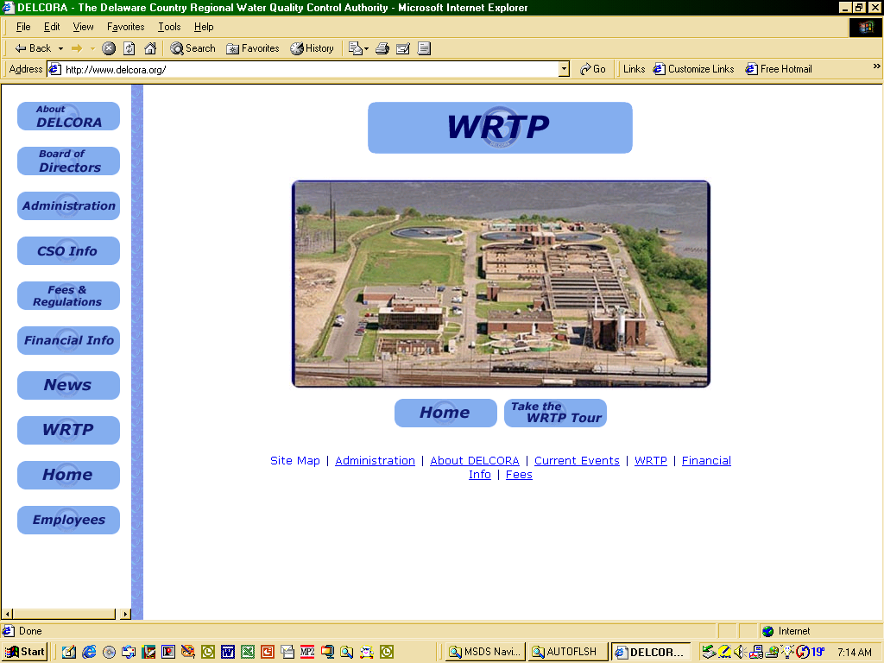
Assembly Area # 2
Assembly Area # 1
    - Primary Assembly Area # 1 Admin building (B-2) Parking Area
    - Secondary Assembly Area # 2 Pump Station #4

Evacuation Plan Page 3 of 4

  - Evacuation Route South
    - Assembly Area #1
      - Main exit, Maple Street to 9th Street
      - Right on 9nd street until Amber Ave.
      - Left on Amber Ave. until Rt. I-101
      - Take Rt. I-101 south to mile marker 74
      - Rendezvous at rest area parking lot
      - Take head count
    - Assembly Area #2
      - Use Emergency exit (rear of PS-4)
      - Left on Amber Ave. until 9nd St.
      - Right on 9nd St.
      - Head north on Rt.148 to exit 5
      - Rendezvous at North Park, main parking lot
      - Take head count

Evacuation Plan Page 4 of 4
EYE PROTECTION

Unit/Area of All Safety First Authority facilities and work sites where a risk of eye
Responsibility: injury exists.

Job Hazards: Eye Injury

Protective Approved shatterproof safety glasses, safety goggles and face shields that
Equipment: comply with ANSI Z87.1 - 1989 standards.

Purpose: To protect the eyes of all personnel who work in hazardous situations where the eyes could be injured. Protection from hazardous work situations include but are not limited to:

- Where there are flying chips or particles present.
- When you work with Chemicals, acids or caustics.
- When there is electrical arching or sparks.
- When working with Molten Metal.
- When there are hazardous chemical gases or vapors present.
- When there is harmful light from welding, cutting, brazing or soldering.
- Where there are dust particles.
- Where there are swinging objects.

GUIDELINES:

- Safety First Authority Employees

  - Must wear Basic Eye Protection in all areas where a risk of eye injury exists.

    - This would include chemical mixing, handling and application areas, work generating flying debris, and entering or looking into manholes where air bags or flush equipment are in use.

    - Basic eye protection is considered to be spectacles or goggles with approved safety glass lenses and safety frames.

  - Safety glass areas should be identified by a caution sign stating:

Caution
Safety Glasses Must Be Worn In This Area

Safety Eye Wear Policy Page 1 of 3

  - Additional eye protection is required when performing work such as welding, grinding, chipping, burning, handling of chemicals, etc. Before work begins your immediate supervisor should be consulted on the proper eye protection required.

  - Work which may involve high frequency power sources, high voltage discharge, ultraviolet or infrared sources, pouring lead, or other similar situations, requires different eye protection. Before work begins your immediate supervisor should be consulted on the proper eye protection required.

- Eye Protection shall meet the following minimum requirements:

  - They shall provide adequate protection against the particular hazards for which they are designed.

  - Safety Goggles should be reasonably comfortable and fit snugly to keep out dust and splashes when worn under the designated conditions.

  - If prescription glasses are worn the safety glasses should fit comfortably over prescription glasses without disturbing the proper position of the prescription or protective lenses.

  - They shall be durable.

  - They shall be easily cleanable.

  - Protectors should be kept clean and in good repair.

  - The elastic bands should be flexible, not stretched out, knotted, twisted or worn out.

  - Persons whose vision requires the use of corrective lenses shall have access to goggles which can be worn over the corrective spectacles or may order prescription safety eyewear. See Safety First Authority’s Prescription Safety Eyewear Program.

A person's eyesight is irreplaceable. All procedures WILL be followed to protect your eyes

Safety Eye Wear Policy Page 2 of 3

SAFETY FIRST AUTHORITY
PRESCRIPTION SAFETY EYEWEAR PROGRAM

Purpose: The purpose of this program is to enhance eye protection of Safety First Authority employees and reduce hazards to the eyes.

Eligibility: Safety First Authority employees who wear prescription eyeglasses and work in areas which require eye protection will be eligible to purchase one pair of prescription glasses every two years.

Eyewear
Allowance $150. Every 2 years. (Exceptions to the 2 year rule: Change in prescription
Amount: or if Eyewear is damaged in the course of work

- Requirements:

  - Eyewear must meet ANSI Z87.1 - 1989, American Standard Practice for Occupational and Education Eye and Face Protection.

  - Transparent lenses only, no sunglasses.

- Process:

  - Employee obtains an eye examination and obtains a prescription for glasses. (Vendor will not fill prescription more than 2 years old).

  - Employee completes a “Request for Prescription Safety Eyewear” form and submits it to his supervisor for approval.

  - After approved by the employee’s supervisor, the form is forwarded to Human Resources to determine if the employee has used his safety eyewear allowance,

  - Once Human Resources reviews the request form, it will be returned to the supervisor to issue to the employee.

  - Employee provides the approved “Request for Prescription Safety Eyewear Form” along with his prescription to the Authority Safety Eyewear Vendor. The employee must pay the vendor directly for any amount over the $150 allowance. The Authority will be direct billed an amount up to $150.

  - Or: The employee selects glasses from vendor of his choice and then provides a detailed receipt along with the approved Request for Safety Eyewear Form to Safety First Authority Accounting Department for reimbursement up to the allowance amount.

Safety Eye Wear Policy Page 3 of 3

SAFETY FIRST AUTHORITY

REQUEST FOR PRESCRIPTION SAFETY EYEWEAR

I wear prescription eyewear and am requesting authorization for participation in the Safety First Authority Prescription Safety Eyewear Program.

Date:______________________

Employee Name:____________________________________________________________

Department:________________________________________________________________

Supervisor’s Name:__________________________________________________________

Approve:
Disapprove:

Comments:_________________________________________________________________

___________________________________________________________________________

Supervisor Signature:__________________________________ Date:_________________
----------------------------------------------------------------------------------------------------------------
HUMAN RESOURCES:

Employee Eligible For Safety Eyewear Allowance:

Yes
No

Human Resources Signature:____________________________ Date:________________

Upon approval and verification of eligibility, employee may proceed to obtain safety eyewear from the Authority Safety Eyewear Vendor or a vendor of his choice. The employee is to provide this form to the Authority Safety Eyewear Vendor when ordering eyewear. If the employee utilizes a vendor other than the Authority Safety Eyewear Vendor, he is to submit a copy of this form with the receipt to Accounting for reimbursement.

Safety Eye Wear Policy Page 1 of 1

FOOT PROTECTION

Unit/Area of All Safety First Authority facilities and work areas except
Responsibility: Administrative Offices

Job Hazards: Foot Injuries

Protective Safety First Authority approved safety shoes must :
Equipment:
- Have a minimum ANSI 75 (compression & impact standards)
- Have a tempered steel shank
- Have a shoe height – minimum 6”
- Have steel or fiberglass safety toe meeting ANSI standard.

- NOT BE A SNEAKER SAFETY SHOE

Purpose: In order to protect feet, toes and ankles from activities that may be hazardous to your feet, safety shoes meeting the safety shoe protective equipment standards are required to be worn in all Safety First Authority facilities and work areas accept the Administrative Offices.

GUIDELINES:

- Safety First Authority Employees

  - Must wear safety shoes where required.

  - Failure to wear the required safety shoes shall subject the employee to disciplinary action.

  - Reimbursement is offered on an annual basis for safety shoes meeting the specific shoe requirements. The “Request for Safety Shoe Reimbursement” form and the required sales slip must be filled out in their entirety.

  - The maximum allowance for shoe reimbursement is reviewed annually.

  - Sneaker Safety Shoes are unacceptable therefore reimbursement will not be given.

Foot Protection Policy Page 1 of 1

REQUEST FOR SAFETY SHOE REIMBURSEMENT

I, request reimbursement for the Safety Shoes indicated purchased by me on the attached sales slip. (NOTE: A CASH REGISTER TAPE IS NOT AN ACCEPTABLE SALES RECEIPT). I understand that sneaker safety shoes are unacceptable and I am expected to wear these shoes in accordance with the Authority policy and believe that these Safety Shoes, for which I am requesting reimbursement, meet all of the required Safety Shoes standards established by Safety First Authority.

NOTE: THE ATTACHED SALES SLIP MUST CLEARLY INDICATE THE FOLLOWING:
1. NAME OF EMPLOYEE PURCHASING SHOES
2. DATE SHOES PURCHASED
3. PURCHASE PRICE OF SHOES
4. SHOE CLASS SPECIFYING COMPRESSION AND IMPACT STANDARDS (MINIMUM ACCEPTABLE IS ANSI 75)
5. TEMPERED STEEL SHANK
6. SOLE COMPOSITION
7. SHOE HEIGHT – 6” MINIMUM

EMPLOYEE SIGNATURE DATE OF REQUEST

I have reviewed the documentation provided by the above named employee and verify that all standards required by Safety First Authority for reimbursement have been met. Please process reimbursement for the purchase price indicated on the attached sales slip. (NOT TO EXCEED THE MAXIMUM AMOUNT IN EFFECT AT THE TIME OF THE PURCHASE).

SUPERVISOR SIGNATURE DATE APPROVED

***NO SNEAKER SAFETY SHOES***

(FORWARD APPROVED REQUEST TO THE ACCOUNTING DEPARTMENT)

MAXIMUM AMOUNT PAYABLE PER YEAR PER PERSON IS $100.00.

Safety Shoe Reimbursement Policy Page 1 of 104

HEAD PROTECTION

Unit/Area of Plant-wide (WTTP) and Street service work
Responsibility:

Job Hazards: Head injuries

Protective Company-issued Class E – G Hard Hats
Equipment:

Purpose: A Class E – G hard hat is highly recommended throughout any plant and pumping station processes because it offers the most electrical resistance, in addition to providing the necessary impact protection. Hard hats are required in the following areas:

- Everywhere there is open grating above.
- Whenever work is performed overhead.
- Street Service Work (Vactors; Bucket Machines; Cranes; Bypass Pumping; Traffic Control; excavations; etc.)
- Work performed below grade level in the street (shallow excavations) or at WTTP.
- All Confined Space Areas.
  - Working in tanks
  - Working in manholes or street openings.
- All Wet Wells
- All areas where a crane is in use.

GUIDELINES:

A. Safety First Authority Employees

1. Must wear only Class E - G company-issued hard hats. These hard hats are available with and without the ratchet adjustment, which offers the advantage of quick loosening or tightening of the suspension.

        - Hard hats must be standard issue obtained from the storeroom.

        - Hard hats do not need to be worn in offices, control rooms, labs, and when inside covered vehicles.

Hard Hat Policy Page 1of 3

        - Hard hats must be worn with the bill in front, as designed, to receive the maximum protection afforded by the hat. Welders are permitted to wear it with the bill in back only while welding with a welder's shield.

        - The suspension is designed to be worn without a liner or only with liners designed for this purpose. Other types of headwear may not be worn under the hard hat (i.e., baseball caps, etc.) as they negate the proper functioning of the suspension.

        - All personnel should periodically inspect their hat for signs of decay, cracks, chips, holes and wear. Any of these could diminish the protection capacity of the hat, and if detected, the hat should be replaced.

        - Approved self-adhesive stickers for individual users to “personalize” their hard hats for identification purposes are common. Adhesive stickers should be placed at least ¾” away from the edge on the helmet.

        - Engraving identification data on the underside of brim is permitted (if approved by the manufacture) but engraving must be restricted to the brim area. Engraving on the shell of the hat will adversely affect the helmets performance.

        - Hard Hat Date Codes are molded into the underside brim of hard hats to indicate when they were molded

          - Date codes specify the Day, Month, and Year the hat or cap was molded. The large arrow inside the "Month/Year" circle points to the month, and the two digits inside that inner circle indicate the year. The arrow inside of the 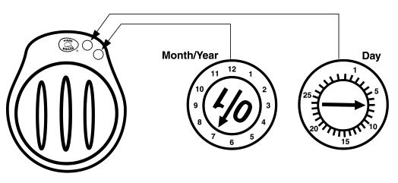
"Day" circle points to day of month. This example shows a cap that was molded on July 7, 2001. Safety First Authority will replace all employees' caps every five years, regardless of the cap's outward appearance.

Hard Hat Policy Page 2of 3

- Contractors and Visitors must also wear hard hats when working or visiting in the plant as outlined above.

  - Hard hats must conform to OSHA Class E or Class E standards.
  - Visitors will be provided with hard hats as necessary
  - Visitor hard hats will be yellow in color.

Following the initiation of the policy a 30 day Moratorium where No Disciplinary Action will take place. After the Moratorium, normal disciplinary actions will be in effect.

Hard Hat Policy Page 3of 3
-33-
HEARING PROTECTION

Unit/Area of
Responsibility: Plant-wide (WTTP) and Street service work where the employee is exposed to noise at or above the 8 hour time weighted average of 85 decibels.

Job Hazards: Loss of Hearing of employees who are exposed to over 85 decibels for over an 8 hour period of time.

Protective
Equipment: Company issued Earmuffs (Quiet 24+) and /or Ear Plugs (Quiet 29-32)

Purpose: To prevent hearing loss of employees by providing hearing protection devices, hearing tests and education courses when indicated. Hearing protection must be worn in the following areas:
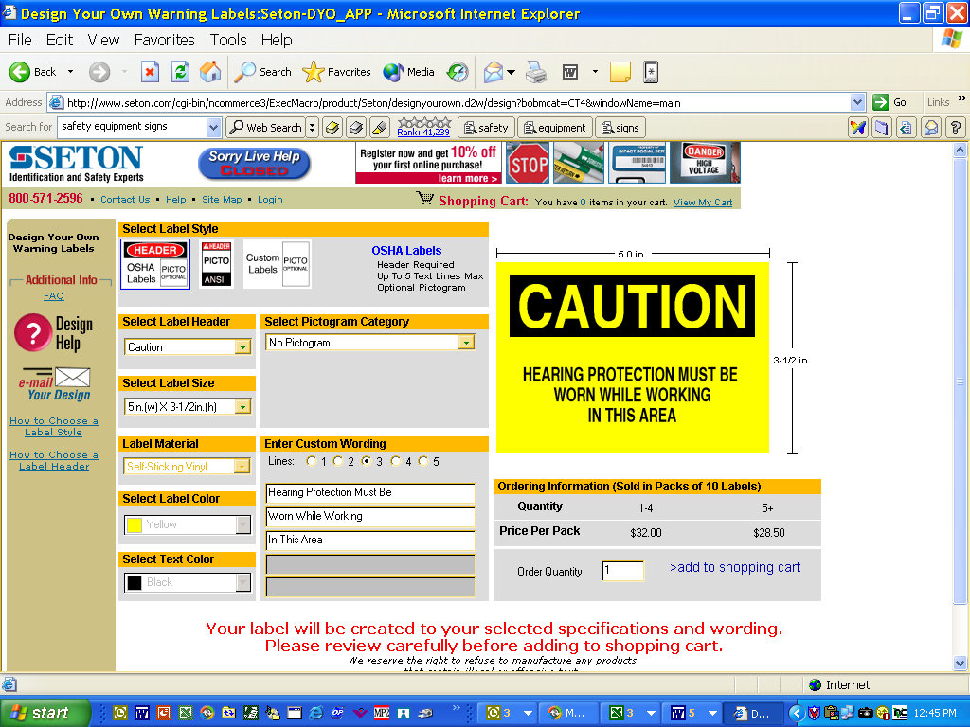
    - Sludge Thickening Room
    - Incinerator Room
    - Grit Removal

GUIDELINES:

- Safety First Authority Employees

  - Affected employees must attend a hearing conservation course.

  - Baseline and annual audiometric testing is conducted by a qualified medical provider.

  - Hearing Protection devices will be provided by the Safety supervisor

Hearing Protection Policy Page 1 of 2

  - The employee must use the devices appropriately.


WARNING!!!!
Once hearing is lost it CANNOT be REPAIRED or REPLACED.

Hearing Protection Policy Page 2 of 2

HOT WORK

Unit/Area of All Safety First Authority facilities and work areas where welding burning
Responsibility: or grinding will take place

Job Hazards: Fire

Equipment: A B C Fire Extinguisher
Fire Blanket
Fire Watch

Purpose: To ensure that no fires will be ignited while using welding, burning or grinding equipment.

GUIDELINES:
- Safety First Authority Employees
  - Will use the Hot Work Permit Check List to fill out the Hot Work Permit.
  - Will fill out and comply with the Hot Work Permit before starting any job that requires the use of welding, burning or grinding equipment.

Hot Work Page 1of 1

MOTOR VEHICLE OPERATIONS

Unit/Area of
Responsibility: Plant-wide (WTTP) and Commercial Street.
Protective
Equipment: Seat belt.
Purpose: To ensure that all Safety First Authority employees perform responsibly and professionally while operation a company vehicle.

Guidelines:

Motor Vehicle Operation

Most employees of Safety First Authority will probably at sometime have reason to operate a Authority owned vehicle. Whatever the purpose for operating an Authority owned vehicle, the operator should strictly obey all traffic laws and all traffic signs. The application of the defensive driving tactics will prevent many accidents from happening.

While operating an Authority vehicle the driver is responsible for its care. At no time, unless in case of emergency will an unauthorized or non-employee be permitted to operate the vehicle.

All accidents must be reported promptly and correctly to the employee's supervisor and to the proper legal authorities.

The driver should perform a brief safety inspection at least daily and a more detailed inspection monthly to detect any defective equipment which could effect the safe operation of the vehicle. Any defects which are found should be reported to the supervisor. If the defect effects the safe operation of the vehicle, the repair should be made before the vehicle is used.

The possession and/or use of alcoholic beverages and illegal drugs are strictly prohibited while using a Authority owned vehicle. Drunken driving is the number one cause of auto fatalities. Any employee drinking alcoholic beverages and/or using drugs, or having possession of the same during working hours or while driving an Authority vehicle shall be subject to disciplinary action.

Employees who are responsible for the operation of Authority owned vehicles shall be required to have and maintain the proper license for the size and type of vehicle operated and the employee must inform his/her supervisor of any change in the status of their license which would effect their ability to legally operate the vehicle. Employees’ drivers records will be check annually through the PA Department of Transportation.

Motor Vehicles Operation Page 1 of 1

NOMEX CLOTHING

Unit/Area of All Electricians, Instrumentation Technicians and Electronic
Responsibility: Instrument Technicians working at any Safety First Authority facility or site.

Job Hazards: Electrical Burns to the body

Protective NOMEX IIIA 4.5 Button Front Deluxe Long Sleeve Shirt and Equipment: NOMEX IIIA 6oz. Work Pant.

Purpose: NOMEX IIIA outer wear is a flame resistant material that will protect the skin in the event of electrical burns.

GUIDELINES:

Safety First Authority Employees

- All Safety First Authority electricians, instrumentation technicians and electronic instrumentation technicians are required to wear NOMEX IIIA uniforms while performing any kind of electrical work at any Safety First Authority facility or site.

- Uniforms are provided by Safety First Authority and it is mandatory for all electricians, instrumentation technicians and electronic instrument technicians to wear them.

- Any Safety First Authority electrician, instrumentation technician or electronic instrument technician not wearing a NOMEX IIIA uniform is subject to disciplinary action.

NOMEX Clothing Policy Page 1 of 2

NOMEX IIIA

6OZ. WORK PANT

Protection: ARC Rating 5.75 ATPV

FABRIC / FEATURES:

- Flame Resistant, 6oz. NOMEX IIIA material
- Inner lined waistband with button closure
- Two slack style front pockets, two set in hip pockets, left hip with button closer
- Permanent Crease
- Autoclaved

NOMEX IIIA
4.5OZ. BUTTON FRONT

DELUXE SHIRT

Protection: ARC Rating 4.8 ATPV

FABRIC / FEATURES:

- Flame Resistant, 4.5 oz. NOMEX IIIA material
- Banded, topstitched collar
- Topstitched cuffs with adjustable button closures
- Pocket Front with button closure
- Tailored sleeve pocket
- Autoclaved

NOMEX Clothing Policy Page 2 of 2

PORTABLE TOOLS AND EQUIPMENT

Unit/Area of
Responsibility: All Safety First Authority facilities and work sites.

Purpose: Portable tools and equipment can be very dangerous when they are not used properly. All safety guidelines are to be strictly adhered to for the protection of the user and any personnel in the immediate area.

GUIDELINES:

- Tool Condition(s)

  - Each employee shall be responsible for checking the safe condition of their tools and equipment prior to use. They shall report any safety hazards to their supervisor immediately.

  - The operator of any portable tool or piece of equipment shall be responsible for keeping it clean, lubricated and in good condition.

  - When a tool develops a defect or malfunction during use, the operator shall immediately stop using it until it is properly repaired.

  - All tools should be inspected at regular intervals and should be repaired in accordance with the manufacturer's specifications.

- Shield Guards and Attachments

  - The proper shield, guard or attachment, as furnished by the manufacturer, shall be used at all times.

  - Portable, power driven saws shall be equipped with guards above and below the base plate or shoe. The upper guard shall cover the saw to the depth of the teeth except for the minimum required to allow the base to be tilted for bevel cuts. The lower guard shall cover the saw to the teeth except for the minimum required to allow proper retraction and contact with the work. When the tool is withdrawing from the work, the lower guard shall automatically and instantly return to the covering position.

Portable Tools & Equipment Policy Page 1 of 2

  - Belt sanding or grinding machines shall be provided with guards at each nip point where the sanding belt runs onto a pulley. These guards shall effectively prevent the hands or fingers of the operator from coming in contact with the nip points. The unused run of the sanding belt shall be guarded against contact.

- Hoses & Connections

  - Hose and hose connections used for conducting compressed air to utilization equipment shall be designed for the pressure and service to which they are subjected. The operating trigger on portable hand operated utilization equipment shall be arranged to close the air inlet valve automatically when the pressure of the operator's hand is removed.

- Required PPE

  - Eye protection shall be worn by all personnel when in the area of or while performing any of the following tasks: grinding, chipping, drilling, sawing or similar operations.

- Required Preparation

  - Every employee should keep up to date and be familiar with the proper use of protective devices used with tools of his or her trade.

  - No employee should use a tool until he/she has been shown how to use the tool correctly and is familiar with the tool(s) operation.

Portable Tools & Equipment Policy Page 2 of 2

RESPIRATORY PROTECTION

Unit/Area of Chlorine Storage Room, Evaporator Room, Areas ODR1 and ODR2, and any
Responsibility: area around the plant where conditions would dictate the use of a respirator.

Job Hazards: Employee could be overcome by chemical vapors or lack of oxygen.

Protective SCBA, Air Supplied Respirator, Air Purifying Respirator and/or Particulate
Equipment: Respirator.

Purpose: To protect the employee from being adversely affected by chemical vapors or
in an oxygen deficient area.

GUIDELINES:

- Safety First Authority Employees:

  - In the water and wastewater industry the most common respiratory exposures are the particulate contaminants (dust) from handling dry chemicals and gas and vapor contaminants from chlorine leaks. Each of these situations requires a special type of protection to prevent adverse health effects. Every employee handling dry chemicals such as dumping bulk or bagged chemicals into feeders or any other condition which creates a chemical dust shall be required to wear a respirator for protection from particulate matter. Every employee who detects or suspects the presence of chlorine gas must put on an air supplied respirator or self contained breathing apparatus (SCBA) or independent oxygen breathing apparatus before entering the suspected area or confined space.

  - Safety First Authority will provide respirators which are applicable and suitable for the purpose intended and will establish a maintenance and training program.

  - The employee shall use the provided respiratory protection in accordance with instructions and training received. The employee shall guard against damage to the respirator, will maintain the respirator in accordance with the manufacturer's recommendations, and shall report any malfunction of the respirator to his or her supervisor.

Respiratory Protection Page 1 of 3

  - Each respirator wearer shall be given training which will include explanation of hazards, the need for respirators to provide protection, the reason for selecting a particular type of respirator, the function and capabilities and limitations of the selected respirator, the method of using the respirator and checking its fit and operation, the necessary respirator maintenance and recognizing and handling emergency situations. Training will be repeated annually and written records of training will be maintained.

  - A respirator will not provide full protection to the wearer, if the wearer is not clean shaven. The wearer of a respirator equipped with a full face piece, helmet, hood shall not be allowed to wear contact lenses. If spectacles, goggle or face shield must be worn with the respirator face piece, it shall be worn so as to not affect the seal of the face piece.

  - Respirator maintenance shall be performed on a schedule which ensures that each respirator wearer is provided with a respirator which is clean and in good operating condition. Maintenance shall include cleaning and sanitizing, inspection for defects, replacement of worn or deteriorated parts, and storage to protect against dust sunlight, excessive heat, extreme cold, excessive moisture, damaging chemicals and physical damage.

  - For the particulate contaminants (dust) caused by dry chemical handling, a particulate removing respirator equipped with a filter or filters specifically designated for the expected type of particulate matter will be provided. The filter may be of the single use or the reusable type.

  - For the gas and vapor contaminant from chlorine leaks, a Air supplied respirator or a self contained breathing apparatus (SCBA) positive pressure type closed circuit respirator will be provided.

SCBA
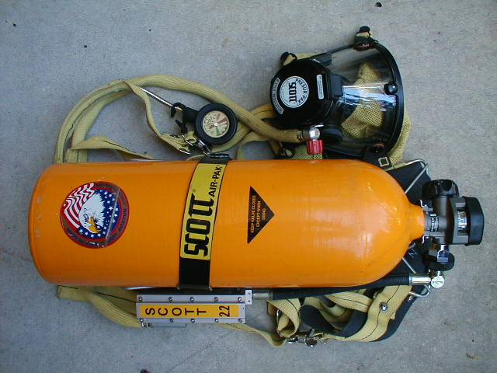

Respiratory Protection Page 2 of 3

  - The self contained breathing apparatus will be stored in a manner to protect them against dust, sunlight, heat, extreme cold, excessive moisture, or damaging chemicals. Respirators shall be stored to prevent distortion of rubber or other elastomeric parts. Emergency and rescue use respirators that are placed in work areas shall be quickly accessible at all times and the storage cabinet or container in which they are stored shall be clearly marked.

  - Each respirator shall be inspected routinely before and after each use. Each respirator stored for emergency or rescue use shall be inspected at least monthly. Respirator inspection shall include a check for tightness of connections, for the condition of the respiratory-inlet covering, head harness, valves, connecting tubes, harness assemblies, and for proper function of regulators, alarms, and other warning systems. Each rubber or other elastomeric part shall be inspected for pliability and signs of deterioration. Each air and oxygen cylinder shall be inspected to ensure that it is fully charged according to the manufacturer's instructions. A record of inspection dates, findings and remedial actions shall be kept for each respirator maintained for emergency or rescue use. Any deterioration
or deficiencies found during the inspection shall be corrected immediately or, if necessary, reported to the immediate supervisor.

  - Air Supplied Respirators using compressed air and compressed oxygen shall be of high purity. Compressed air cylinders shall only be refilled by compressors specifically constructed for this purpose and which will avoid entry of contaminated air into the air supply system.

Air Supplied Respirator
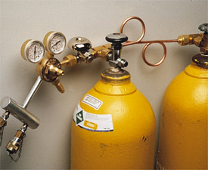
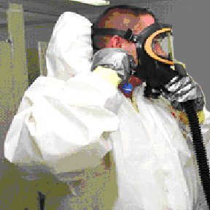

Respiratory Protection Page 3 of 3

THE WORKER AND COMMUNITY
RIGHT TO KNOW ACT

Unit/Area of All Safety First Authority facilities and associated street locations where
Responsibility: Authority employees are working.

Job Hazards: Each chemical has its own kinds of hazards. It is the employee’s responsibility to know what the hazards are by reading the MSDS sheets provided by the chemical manufacturer.

Protective
Equipment: As dictated by the MSDS.

Purpose: The purpose of this law is to ensure that the hazards of all chemicals produced or imported by chemical manufacturers are evaluated and the information concerning these hazards is transmitted to affected employees in order to reduce the incidence of chemically-related illness and injuries. This transmittal of information is to be accomplished by means of comprehensive hazard communication programs, which are to include container labeling and other forms of warning, material safety data sheets, and employee training. Workers have a right to know about chemical hazards to which they may be exposed.

LABELS

Containers are to be labeled, tagged or marked..

Each container present in the work areas shall be labeled, tagged, or marked with the common or chemical names of the hazardous chemicals contained and its appropriate hazard warnings.

Portable containers into which hazardous chemicals are transferred from labeled containers for the immediate use of the employee who performs the transfer are exempt from these requirements.

Labels should list precautions in the following categories. After reading the label, you can check the Material Safety Data Sheet (MSDS).
    - Basic Warnings. The warning label lists the chemical name, hazardous ingredients, and the name and address of the chemical manufacturer. It also lists hazard warnings, such as to keep the chemical away from flame or avoid skin contact.
    - First Aid. The label may explain what to do if you splash the chemical in your eyes or on your skin. You may need to flush your eyes at an eyewash station for 15 minutes or wash contaminated skin in a full-body shower.

Right To Know Page 1 of 4

    - Fire. The label may tell you what to use to put out an accidental fire. There are four different types of fire extinguishers: water spray, foam, dry chemical, and carbon dioxide. Using the wrong one can spread the fire rather than put it out, so be sure you check the warning label.
    - Spills. There may be a section on how to handle spills. For any spill, contact your supervisor right away and put out any source of nearby flame. You may need to wear personal protective equipment to clean up a spill.
    - Handling and Storage. The label may list the personal protective equipment, such as gloves, safety goggles, or a respirator, that you need to handle the chemical safely. The chemical may also need to be stored with extra ventilation or away from other chemicals.
    - Disposal. Treat empty containers as if they're full, and don't fill them with anything else! Empty containers can be hazardous since they often hold residues that can burn or explode. Follow the label and your Authority policy on how to dispose of empty containers.
  - Label Missing or Torn.
    - Non-Labeled Containers. If a container doesn't have a warning label, don't handle the chemical until you know what it is. Report the situation to your supervisor, who will find out what the chemical is and provide a warning label if the chemical is hazardous.
    - Transfer Containers. If you move a hazardous chemical from its primary container to a new one, be sure your transfer container is labeled. Then your coworkers will know how to handle it safely too.
    - Torn Labels. If a label is torn, damaged, or misplaced, ask your supervisor to replace it. Remember, the only way you can handle a chemical safely is if you know what it is.

- MATERIAL DATA SHEETS
  - Each employer shall maintain in each work place a material safety data sheet or similar informational reference for each hazardous chemical which they use. All material safety data sheets maintained by the employers shall be available to their employees for examination during all hours of operation.
  - Material Safety Data Sheets (MSDS) will contain information in the following categories for each hazardous chemical.
    - Chemical Identification. The first section of the MSDS helps you identify the chemical. It lists the name of the chemical, any trade names, and the chemical manufacturer's name and address. This section may also list an emergency phone number.
    - Hazardous Ingredients. This section lists what's in the chemical that can harm you. It also lists the concentration of the chemical to which you can safely be exposed, often listed as the permissible exposure limit (PEL) or the threshold limit value (TLV). These safe exposure limits are usually figured for average exposures over a typical work shift
Right To Know Page 2 of 4

    - Physical Data. This section describes the chemical's appearance, odor, and other characteristics. Percent volatile, for instance, is how much of the chemical evaporates at room temperature. Sulfuric acid has a low percent volatile, but it can be harmful if inhaled. Respiratory protection or extra ventilation may be needed.
    - Fire and Explosion Data. Here you can find at what temperature the chemical ignites, called the flash point. If a chemical is flammable, it ignites below 100°F. If it's combustible, it ignites at 100°F or above. This section also lists extinguishing media - what will put out the fire safely - such as water spray, foam, or other types of fire extinguishers.
    - Health Hazards. This section lists symptoms of overexposure, such as a skin rash, burn, headache, or dizziness. It also tells you first aid and emergency procedures in case of overexposure, such a flushing your exposed skin with running water for 15 minutes. It may also list any medical conditions that can be aggravated by exposure to the chemical.
    - Reactivity Data. Here you'll find whether the chemical "reacts" with materials or conditions. Incompatibility lists the materials, such as water or other chemicals that cause the chemical to burn, explode, or release dangerous gases. Instability lists the environmental conditions, such as heat or direct sunlight that cause a dangerous reaction.
    - Spill or Leak Procedures. This section tells you what to use to clean up an accidental spill or leak. No matter what the chemical is, always notify your supervisor right away. Before cleaning up a chemical spill, you may need to wear respiratory protection, gloves, safety goggles, or protective clothing. This section may also include notes on how to dispose of the chemical safely.
    - Special Protection. Here you'll find a listing of any personal protective equipment (respiratory protection, gloves, eye protection) you need to work safely with the chemical. If protective equipment is needed, this section may list the specific types that are recommended, such as a full-face mask respirator, rubber gloves, and chemical safety goggles.
    - Special Precautions. This section lists any other special precautions to follow when handling the chemical. This may include what to have nearby to clean up a spill or put out a fire, and what safety signs to post near the chemical. This section also lists any other health and safety information not covered in other parts of the MSDS.

- EMPLOYEE INFORMATION AND TRAINING
  - Supervisors are required to provide information and training on hazardous chemicals in their work area.
  - The information and training shall commence prior to an employee's initial assignment. Additional instruction shall be provided whenever chemicals or processes change or newly acquired information indicates the need for additional protective measures. Programs shall be conducted during the employee's regular working hours.

Right To Know Page 3 of 4

  - The information and training program shall include the following:
    - The provisions of this Act;
    - A discussion of operations in the work area where hazardous chemicals are present;
    - Methods of detecting the presence or release of hazardous chemicals in the work area;
    - The physical and health hazards of the chemicals in the work area;
    - The location and availability of the written hazard communication program and related documents;
    - The measures employees can take to protect themselves from these hazards including the purpose, proper use, and limitation of personal protective equipment;
    - An explanation of the labeling system and material safety data sheets;
    - Emergency procedures, methods and observations - such as visual appearance or smell - employees can use to detect the presence of a hazardous chemical they may be exposed to.

- ACCESS TO WRITTEN RECORDS
  - Chemical identification lists and material safety data sheets required by this Act shall be made available upon request for examination and copying to any affected employee or former employee, authorized employee representative, designated physician or representative.
  - Any exposure measurements taken to monitor employee exposure to chemicals in the work area shall be made available upon request for examination and copying to any affected employee or former employee, designated physician or representative.
- PROHIBITED PRACTICES
  - It is unlawful for any employer to discharge, discipline, or otherwise discriminate against any of its employees who have assisted in the enforcement of this Act.

Right To Know Page 4 of 4
SEAT BELTS

Unit/Area of All Safety First Authority vehicles, Safety First Authority rental vehicles and
Responsibility: personal vehicles on Authority business.

Job Hazards: Accidents can happen any where including on plant premises.

Purpose: To prevent or lessen injury in the event of a vehicle accident.

GUIDELINES:

A. Safety First Authority Employees

- Seat Belts must be worn by anyone operating or riding in company vehicles at ALL times. (NO EXCEPTIONS)

- Pennsylvania State Law states both driver and passengers must wear seat belts at all times. It is the employees’ responsibility to abide by the Law.

- Personal Vehicles used for Authority business – Personal Vehicles used for Authority business shall provide a seatbelt for the driver and all passengers. It is the Law for seatbelts to be worn by any one in a vehicle. This applies to personal vehicles on Authority business.

- Orange seat belt pads show whether seat belts are in use or not


Seatbelt Policy Page 1 of 1

SHORING

Unit/Area of
Responsibility: Plant-wide (WTTP) and Street service work

Job Hazards: When working in excavations, the soil and or weather conditions could create the possibility of cave-ins.

Protective
Equipment: Speed Shoring, fin form plywood, ladders & trench boxes.

Purpose: To protect workers from cave-ins when working in trenches or pits.

GUIDELINES:

- Determination Of Soil Type
  - Stable Rock - Granite or Limestone
  - Type “A” Soils - Clay (1.5 tsf)
  - Type “B” Soils - Angular gravel, Silt (.5 tsf to 1.5 tsf)
  - Type “C” Soils - Gravel, Sand, Submerged soil (.5 tsf or less)
- Soil Weight
  - Heavy soil may weigh up to 100 lbs./ cu. ft.
  - Cubic yard of soil contains 27 cu. ft.
  - At 100 lbs./cu.ft., a yard of soil will weigh 2,700 lbs. nearly 1 1/2 Tons
- Conditions Causing Soil Distress
  - Placing spoils closer than two feet from open trench
  - Nearby vibrating machinery
  - Nearby heavy, moving loads
  - Seeping water or rain
  - Hot, dry weather
- Excavation Inspections
  - Inspections must be conducted
    - Before work starts
    - Throughout shift
    - After a rainstorm
Shoring Page 1 of 4

  - Excavations must be inspected for;
    - Evidence of possible cave-ins
    - Indications of failure of protective systems
    - Potential hazardous atmosphere
  - Ladder must be installed in trench before workers can enter.
  - Ladders must be installed every 25 feet of trench length.
  - When hazardous conditions are found, remove workers immediately.

- Installing Removing Shoring

  - Follow the steps below when installing & removing shoring of sheathing whalers & struts.

Shoring Page 2 of 4
Installing Vertical Aluminum Hydraulic Shoring
- Note: Don’t enter excavation until at least two pieces of speed shoring are installed.
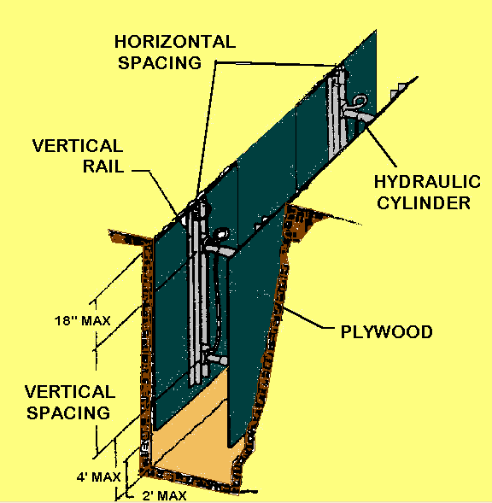

  - Aluminum Hydraulic Shoring Waller Systems for Soil Type B

Shoring Page 3 of 4

2. Aluminum Hydraulic Shoring Waller Systems for Soil Type C

Shoring Page 4 of 4

SKIN PROTECTION

Unit/Area of All Safety First Authority facilities and work areas except
Responsibility: Administrative Offices

Job Hazards: Blood and sewage are two very big carriers of disease. Blood and Sewage both can contain Blood Born Pathogens

Purpose: To prevent the spread of disease by direct contact with substances of a foreign nature.

GUIDELINES:

- Safety First Authority Employees

Personal Protective Equipment
    - If you should have to come in contact with blood or sewage, we have two means to protect your skin and clothes:
      - Rubber Gloves: Rubber gloves are located in the storeroom, all first aid kits and at various locations on the plant.
      - Paper Suits: Located in the store room. Made from Tyvek, these suits will protect your clothing and the rest of your body as well.
- Potential Exposure
    - If your skin should come in contact with blood or sewage you should:
      - Scrub the affected area with anti-bacterial soap
      - Tell a foreman or supervisor immediately, you may have to go to the hospital for blood tests or further treatment
- Decontaminating
    - Remove contaminated PPE or clothing as soon as possible
    - Properly dispose of contaminated items
    - Clean and disinfect contaminated equipment and work surfaces
      - Use 1/4 cup of bleach per one gallon of water
      - Let bleach sit for at least 20 minutes before cleaning up.

Skin Protection Policy Page 1 of 1

SMOKING POLICY

Unit/Area of
Responsibility: All Safety First Authority facilities, vehicles, and work sites.

Purpose: In the interest of personal and public safety, housekeeping, health, and welfare the Authority hereby establishes a no smoking policy for all Authority buildings and vehicles. Smoking is allowed only at designated areas as listed below during employee lunch and other authorized break periods.

There are no allowances for smoking
in any control room or control type of area.

No smoking in Authority Vehicles.

GUIDELINES:

- Sites designated by the Authority as permitted smoking areas are:

  - Administration Building
    - Employee parking lot at gate area.
  - WTTP (B2)
    - Outside any of the five entrances by receptacles.
  - WTTP (B3)
    - Outside any of the entrances where receptacles are placed.
    - Inside at the designated smoking area with exhaust fan on.
  - WtTP Pump Station Areas
    - Outside where receptacles are placed.
  - Individual Pumping Stations
    - Outside where the station butt bin is situated.

Smoking Policy Page 1 of 1

ACCIDENT INVESTIGATION

- Scope: To investigate the accident as soon as possible after it has taken place.

- Purpose: The primary purpose of accident investigation serves to gather information about an accident so that a problem that led to the accident can be identified and a solution to that problem developed to prevent a reoccurrence. Accident investigation is fact finding - not fault finding.

  - Safety First Authority has developed an Accident Investigation Report form for utilization in accident investigations. These forms are to be used in addition to the worker compensation form when an injury occurs. They are also to be used for "accidents" that do or do not result in personal injury. The forms are to be made accessible to all employees for non-injury accident reporting. Names do not have to be reported for these "accidents". The originals are to be kept on file in each facility and a copy sent to the Personnel office. Please remember the difference between a non-injury and an injury accident and that our goal is to prevent accidents.

- Application:

  - Ensure all personnel are safe and no medical attention is necessary. If medical attention is necessary attend to the victim and if necessary call 911.

  - Tape off the accident scene to prevent changes in any of the conditions.

  - Start the investigation as soon as possible. Ideally have three (3) people perform the investigation. One (1) supervision and two (2) union/non-supervisor.

  - Use Safety First Authority Accident/Incident or Near Miss Investigation Report to conduct the investigation.

  - Use the six questions for investigating the accident. Ask each person the same questions.

    - Who: What person or persons were involved in the accident?

    - When: What time did the accident occur?

    - How: What is the sequence of events that lead up to the accident? (timelines)

    - What: What were the causes of the accident?

    - Where: What was the location of the accident?

    - Why: Did something go wrong that caused the accident?

Accident Investigation Policies Page 1 of 2

  - Do not come to a conclusion before getting all questions answered.

  - All three investigators should come to a unanimous conclusion on how and why the accident occurred.

  - Using the findings institute a short term solution to prevent another accident from occurring.

  - Forward findings to Supervisor for review and long term solutions.

Accident Investigation Policies Page 2 of 2

ACCIDENT/ INCIDENT OR NEAR MISS REPORT DIAGRAM AND FORM
Production Name | Safety First Authority WTTP
Address of Accident/Incident | 321 Capital St., Safe City, PA 12345
Production Phone/Fax | Tel (717) 555-1234 Fax (717 555-4321
Date/Time of Incident | Date: Time: AM/PM
Employee Name
Occupation / Department
Reported to Supervisor | Date: Time: AM/PM
Describe how the accident/incident or near miss occurred. (attach additional sheets as necessary)

Safety Equipment used:

Were emergency dept. and the WCB notified or called in? Yes No
Were the Supervisor & Manager notified immediately? Yes No
Witnesses/other person(s) involved:

List any additional pertinent information concerning this injury/illness or near miss.

Should the set be left undisturbed for investigation purposes? Yes No
What actions, if any, have been taken?

Investigated By: Date: |  | Tel ( )
Reviewed By: Date: |  | Tel ( )
Recommendations:

Accident/Incident or Near Miss Investigation Report Page 1 of 2

SCALE: NORTH

PRODUCTION COMPANY: Date:
Time
Description and Location of Hazard /Incident /Near Miss:
_

Suggested or Recommended Action:
(Record any intermediate steps taken to address hazard /incident /near miss)

Other Comments (Attach additional information on a separate sheet):

Hazard/Accident /Near Miss Reported By:
**MAY REMAIN ANONYMOUS"
To be handed to either a safety committee representative or your supervisor.
THIS SECTION TO BE COMPLETED BY MANAGEMENT REPRESENTATIVE

CORRECTIVE ACTION (Describe who will correct the situation, what will be done. and when):

COMMENTS:

Management Representative: Date:

Accident/Incident or Near Miss Investigation Report Page 2 of 2

- Scope:

  - The intent of this procedure is to ensure communication among all parties involved in work in a designated confined space. This will include the entry supervisor, attendant and authorized entrant(s).

- Purpose:

  - This procedure covers the initiation, preparation, authorization, issuance, utilization and termination of confined space entry permits. In addition, this procedure addresses general rules regarding work in confined spaces at Safety First Authority facilities.

- Hazards:

  - Hazardous atmospheres, sudden flow surges or sudden release of energy, inability to isolate spaces, fall hazards.

- References:

  - Water Environment Federation publication – Confined Space Entry

Definitions:

- Attendant – A person stationed outside the permit-required space who monitors the safety of the operation and has duties specified on the Entry Permit form.

- Authorized Entrant – Employees and/or contractors who are authorized by the Entry Supervisor to enter the confined space.

- Blanking and Bleeding. Blanking is the process of placing a physical barrier to stop the flow of materials and ensure that this cannot unintentionally be removed. This is usually accomplished by affixing a solid plate into a flanged connection or at the end of an open pipeline, then securing it in place by re-bolting the connection. Bleeding is the removal of any residual material or energy from the source. In these cases, a tag and/or lock will be attached to alert others that these devices are in place to ensure safe work conditions. This procedure is often referred to as a part of Lockout/Tag out.

- Confined Space – Any space that is large enough and configured to allow a person to enter and perform work, has limited means of entry and exit, and is not designed for continuous personnel occupancy.

Confined Space Procedure Page 1 of 9

- Confined Space Entry Permit – A specific work permit form to ensure that entry into a confined space is authorized and executed subject to specified safety regulation

- Entry - The action by which a person passes through an opening into a confined space. Entry includes ensuing work activity inside the space and is considered to have taken place as soon as any part of the entrant’s body breaks the plane of the opening into the space.

- Entry Supervisor – For work inside the Chester facility, this will be the Operations Shift Foreman, or Maintenance Supervisor, Foreman or designee. He/she will review the hazards with entrant(s) and attendant(s), and will authorize and terminate the entry. For sewer entry work, this will be the Sewer Maintenance Supervisor or Foreman or designee.

- Fall Protection – a device designed to limit the travel distance of a person who falls from a ladder or working surface. This may be a self-arresting device built into a tripod/winch assembly, a separate self-arresting device, or a harness equipped with a shock-absorbing lanyard. These devices reduce the shock-load to the body and the associated injuries. Those personnel who must descend more than four feet into a confined space will be required to utilize fall protection.

- Hazardous Atmosphere – Oxygen level <19.5% or >23.5%, >10% LEL, biological or toxic contaminant above OSHA PEL levels.

- IDLH – Immediately Dangerous to Life and Health. A condition that poses an immediate or delayed threat to life, or that would cause irreversible adverse health effects, or that would interfere with an individual’s ability to escape unaided from a confined space.

- Isolation – The process by which a confined space is removed from service and completely protected against the release of energy and/or material into the space by such means as: Blanking or blinding; miss-aligning or removing sections of piping, tubing or ducts; a double block and bleed system; lockout/tag out of all sources of energy; blocking or disconnecting all mechanical linkages

- LEL – Lower Explosive Limit, or lowest concentration of a gas in air capable of being ignited when a source of energy such as a spark or flame is applied.

- PEL/TLV – Permissible Exposure Limit/Threshold Limit Value. Both are time weighted average concentrations for an eight-hour workday, to which an average worker may be exposed without adverse health effects.

- Permit-Required Confined Space – An enclosed or partially enclosed space such as a tank, skimmer pit, clarifier, pump pit, lift station, furnace or other enclosure where there is reason to anticipate a potential or known hazard to personnel. This will include any open top space more than four feet in depth such as a sewer, valve pit or excavation.

Confined Space Procedure Page 2 of 9

- Retrieval System – Equipment designed to assist in the escape of personnel from a confined space when they are unable to do so unaided. This normally consists of a tripod and a winch or device that provides a mechanical lifting advantage for personnel outside the space who may be involved in non-entry rescue. This is also used in routine entries where there is no other means of entry/exit such as a ladder.

- Ventilation – The use of mechanical or natural air movement to ensure that a hazardous atmosphere does not develop during entry operations.

- Confined Space Permit:

  - When it has been determined that a confined space must be entered, a written permit will be completed. The Entry Supervisor will complete the permit. The purpose of the permit is to provide a checklist of necessary actions to alleviate potential hazards and to provide a vehicle to help ensure work and safety requirements have been effectively communicated. The permit will list the Entry Supervisor and the Attendant(s). The Entry Supervisor will list the work to be performed, the equipment to be used during entry and the precautions to be taken. A copy of the completed entry permit will be posted at the job site and at the Entry Supervisor’s office. The Entry Supervisor and Attendant(s) will sign permits. A roster will be attached to keep an accurate account of entrants.

- Pre-Entry Procedures:

  - Work should be evaluated to determine if entry is necessary, or if the work can be performed without actually entering the confined space. If the space must be entered, atmospheric testing must be performed to determine the presence or absence of a hazardous atmosphere. Atmospheric testing equipment such as gas detectors should be calibrated and set-up away from the work area. Testing probes should be inserted into the space with checks being made at various levels to determine if any heavier-than-air or lighter-than-air contaminants are present. Continuous monitoring of the space may be necessary. Initial monitoring can be done through vent holes in the cover if they exist or by providing entry personnel with testing equipment.

  - For all confined spaces, whether in plant, at pump stations or in sewer entries, steps will be taken to ensure the following atmospheric conditions:

    - Oxygen level – 20.8%. This is the desirable level of oxygen, and can usually be achieved through proper ventilation. Atmospheres of less than 19.5% oxygen will require the use of air-supplied respirators.

    - Flammability – 0%. OSHA allows for up to 10% LEL. Any level above 0% should be investigated and eliminated where possible by ventilating the atmosphere and/or removing ignition sources.

Confined Space Procedure Page 3 of 9

    - Carbon Monoxide – 0 ppm. The permissible exposure limit (PEL) is 35 ppm. Higher levels can present respiratory difficulty, or death.

    - Hydrogen Sulfide – 0 ppm. H2S has an odor similar to rotten eggs. However, it can deaden the sense of smell and give a false sense of security. Ventilation or respiratory protection may be required. Under NIOSH guidelines, levels in excess of 10 ppm will require the use of air-supplied respirator (SCBA or SAR).

  - In a vertical entry more than four feet deep, fall protection, including a full-body harness and a fall-arresting device must be used. Existing tripod/winch assemblies have fall-arrest built in, although care should be taken to use a tripod and winch of the same manufacturer to ensure compatibility. If there is a potential chemical hazard, such as chlorine or caustic, the specific chemical hazards will be reviewed with the entrants. Testing for specific chemicals must be performed when necessary in order to establish exposure potential and PPE requirements.

  - Confined spaces will be ventilated prior to entry. The preferred method is positive ventilation, or blowing fresh air into a space. Exhausting air can allow toxic materials to be sucked into the space from other entry lines. If the cover has no vent holes, use of proper tools and proper lifting procedures can prevent injury to personnel in removing covers. Atmospheric monitoring can then proceed. Once the space has been ventilated, the atmosphere must be re-tested. If the entry involves a sewer on a municipal roadway, the area should be barricaded and identified to alert vehicle traffic and protect workers from traffic hazards. Barriers can also help prevent accidental falls and the inadvertent dropping of foreign objects into the space.

  - Proper isolation or lockout/tag out must be completed to prevent the flow of material and/or the sudden release of energy in a confined space. This includes locking and tagging out electrical sources, blanking and bleeding pneumatic and hydraulic lines, disconnecting belt or chain drives and mechanical linkages on shaft driven equipment, and securing mechanical moving parts within a confined space using chains, blocks chocks or other devices. Tags should be used to alert others that specific lines or equipment have been isolated.

  - The space must be evaluated for the use of personal protective equipment (PPE), specialized entry equipment, emergency or rescue equipment and decontamination requirements. PPE includes the potential need for head, eye, body and foot protection. The need for hearing or respiratory protection must also be considered. Entry equipment includes harnesses, lifelines, and retrieval systems with fall protection, artificial lighting, air monitoring equipment, ventilators and the possibility of non-sparking tools or a fire extinguisher.

Confined Space Procedure Page 4 of 9

  - A means of calling for emergency help must be established. During normal work hours, a Safety First Authority dispatcher is on duty and can be reached via radio. During off-hours, a cell phone must be available contact the local 911 dispatcher. While emergency help is responding, retrieval systems may be used for non-entry rescue or for assistance in self-rescue. In no case will the attendant enter the confined space unless relieved by another qualified person.

  - Decontamination procedures will be discussed prior to entry. This can mean a place to change apparel, or it can be shower and complete hygiene facilities. If the confined space is known to contain certain toxic or biologically active materials, decon facilities should be located at or near the job site whenever possible. Skin barrier creams can be used prior to entry and portable-washing facilities can be available to expedite decontamination where necessary. Personnel will not eat, drink or smoke prior to decontamination.

  - Prior to entry, the Entry Supervisor will perform the following duties and document them on a pre-entry checklist:

    - Evaluate job site for known or potential hazards to entrants. Verify that all monitoring has been completed and that all procedures and equipment specified are in place prior to endorsing the permit and allowing entry to begin.

    - Establish a list of authorized entrants and attendants, and communicate appropriate hazard information.

    - Ensure all safety precautions are taken and permit requirements are met and safe entry conditions are in place.

    - Verify that rescue or emergency services are available and that a means of summoning them is operable.

    - Terminate or cancels the permit when entry operations are complete or a condition not allowed by the permit arises.

- Entry Procedures:

  - In general, a minimum crew of two persons will be used for in-plant entries. A three- person crew will be used for confined space entries at pump stations or for sewer maintenance entry. All safety equipment mandated by the Entry Supervisor will be used, and the confined space will be entered by one of three means:

  - Fixed steps or ladders – check for step and ladder integrity before using. Sewer environments in particular can contribute to corrosion problems, causing rungs or steps to deteriorate.

Confined Space Procedure Page 5 of 9

  - Portable ladders – these may be necessary if fixed ladders are inadequate or not available. Portable ladders should be secured wherever possible.

  - Man-rated mechanical entry/retrieval equipment – tripod/winch assemblies with built-in fall arrest protection.

  - Authorized entrants must meet the following criteria:

    - Know the hazards that may be encountered during entry, including the mode, signs or symptoms and consequences of exposure.

    - Properly use equipment specified in the permit, including proper personal protective equipment (PPE).

    - Communicate with attendant as necessary and knows emergency evacuation signal and procedures.

    - Alert the attendant whenever a warning sign or symptom of exposure to a dangerous situation occurs, or if he/she detects a condition not allowed by the permit.

    - Exit the space whenever the evacuation order is given or if a hazardous condition arises.

  - An attendant will be posted outside the space at all times that entry work is in progress. The attendant will monitor activities inside and outside the space, and will keep an accurate account of personnel entering or leaving the space. In most cases, this will result in a direct line-of-sight contact between the attendant and entrant(s). When direct line-of-sight is not possible; a means of communication must be established that will effectively monitor the safety of all entrants. This can be radio, tugs on a rope or safety line, knocking on the wall of the space, or any system that has been pre-designated by the Entry Supervisor to establish communications.

  - The Attendant’s responsibilities will include:

    - Know the hazards that may be encountered during entry, including the mode, signs or symptoms and consequences of exposure.

    - Is aware of behavioral effects of exposure to hazards.

    - Maintain an accurate account of entrants and maintains a log of names, time in and time out of the space.

    - Remain outside the space until relieved by another qualified attendant, or until entry operations are terminated.
Confined Space Procedure Page 6 of 9

    - Communicate with entrants as necessary.

    - Monitor conditions inside and outside the space to determine if safe conditions exist and orders evacuation of the space if:

      - A prohibited condition is detected

      - A condition outside the space endangers entrants

      - A behavioral effect of exposure is detected

      - A attendant cannot safely perform all assigned duties.

    - Verify that emergency services are available and summons rescue/emergency services as soon as the need is determined.

    - Ensure unauthorized personnel do not enter the space or informs the entry supervisor if unauthorized personnel do not leave the space.

    - Assist entrant by performing non-entry rescue if entrant cannot self-rescue.

    - Perform no duties that may interfere with primary responsibility to monitor and protect entrants.

  - A confined space will be evacuated immediately whenever:

    - An attendant or entrant observes a condition that is prohibited on the entry permit.

    - The gas detector registers unacceptable conditions or goes into the alarm mode.

    - The attendant observes a situation outside the space that can endanger entrants.

    - The attendant or entrant detects an uncontrolled hazard within the space.

    - An entrant or the attendant detects symptoms of exposure to a hazardous atmosphere, such as dizziness, blurred vision, shortness of breath, ringing in the ears, drowsiness, etc.

    - The attendant cannot effectively monitor the safety of entrants.

  - When the space is vacant, the entry supervisor will ensure barriers and signs are in place to prevent unauthorized or accidental entry into the space.

Confined Space Procedure Page 7 of 9

- Termination Of Entry:

  - An Entry Permit will expire at the end of the current shift, and will not be valid for longer than eight (8) hours. A permit will be suspended any time an evacuation order is given, or a prohibited condition is detected. Before entry operations can resume, all pre-entry procedures must be re-checked and the atmosphere re-tested.

  - Once all work in a confined space has been completed, the entry permit will be terminated. The time and date of completion will be entered on the permit, and the completed permit will be returned to the Entry Supervisor, who will forward it to the Safety Manager for review and file. Completed permits will be kept on file for a period of at least one-year.

APPENDIX:

    - Atmospheric Hazards These are usually the most dangerous, yet they will frequently go unnoticed. Personnel often rely on the sense of smell due to the presence of septic conditions or spoiled food often found in sewer systems. However, other gases and vapors that may be hazardous to the respiratory system are odorless and may be toxic or flammable. Some gases can deaden the sense of smell, giving the worker a false sense of security. An atmosphere may be hazardous for no other reason than a deficiency of oxygen, which could lead to a worker exercising poor judgment or disorientation and, ultimately, injury or death.

- Biological Hazards There is no limit to the variety of viruses and bacteria that can exist in wastewater or sewage. Exposure can be aggravated by the existence of open cuts that would facilitate infection. Proper PPE is a must.

- Electrical Hazards Workers in pumping stations often are in close proximity to high-voltage electricity and water. This can be a dangerous situation if not handled carefully. Short circuits and electrical fires can occur with little or no warning, presenting danger to workers and rescuers. Proper isolation of energy sources via lockout/tag out procedures is a must.

- Extreme Temperatures Normally, temperatures inside a manhole are somewhat pleasant. However, protective clothing and equipment can cause the retention of body heat and potentially cause dehydration. Personnel in a manhole should not eat food or drink water until after exiting and decontaminating. Therefore, it is important for personnel to drink plenty of fluids prior to entering manholes in order to prevent dehydration. Personnel will not enter the incinerator hearths when the air temperature is 130°F or higher. It must be recognized that, even when the air temperature is below that level, there may be hot surfaces that require proper personal protection.

Confined Space Procedure Page 8 of 9

  - Hazard Recognition: Some hazards apply to all types of confined spaces. Sewer systems have the potential to present many different hazards. Knowing the hazards is the first step in being prepared for an emergency. Various hazards are described in the following sections.

- Mechanical Hazards This type of hazard is usually found in pumping stations, where machinery, door latches and other mechanical equipment can cause serious injury if not properly isolated. In addition, noise from machinery can cause hearing damage, or interfere with communication between workers. Some mechanical devices must be moved in order to make entry into a confined space. Many of these are heavy, and can lead to strains, sprains or other injuries if not properly handled.

- Physical Hazards Workers must be constantly alert to the potential for physical dangers such as corroded or damaged steps or ladder rungs normally used for entry into, or exit from a confined space. Such damage can lead to falls by personnel or falling objects that can strike personnel and cause injury. Other conditions or equipment such as valves valve stems, valve handles, conveyors or movable objects can result in injury to personnel if not properly isolated. This equipment may be configured in a manner that requires unusual body positioning in order to perform work on it, potentially increasing the possibility of injury if proper caution is no taken. Under the best circumstances, footing can be treacherous and care must be taken.

- Traffic Hazards. These can be hazardous conditions even before any work begins. Many manholes are located in the middle of busy highways. This presents potential hazards to workers and rescuers. Steps must be taken to alert motorists that work in the area presents a potential hazard. Signs, barriers and warning devices must be used appropriately to preserve work zone safety.

Confined Space Procedure Page 9 of 9
LOCKOUT/TAGOUT

- Scope:

  - Any servicing and/or maintenance of machines or equipment when the source of energy to the machines or equipment is electrical, mechanical, hydraulic, pneumatic, chemical, thermal or other energy.

  - Constructing, installing, setting up, adjusting, inspecting, modifying, maintaining and/or servicing machines or equipment including lubrication, cleaning or un-jamming of machines or equipment, and making adjustments or tool changes, where employees could be exposed to the unexpected energizing or startup of the equipment or release of hazardous energy.

- Purpose:
  - To prevent injury to servicing and/or maintenance employees due to the unexpected energizing or startup of machines and equipment, or release of stored energy.

- Application:
  - This standard applies to the control of energy during servicing and/or maintenance of machines and equipment when:
    - An employee is required to remove or bypass a guard or other safety device.
    - An employee is required to place any part of his or her body into an area on a machine or piece of equipment where work is actually performed upon the material being processed (point of operation) or where an associated danger zone exists during a machine operating cycle.
- References:
  - OSHA - Control of Hazardous Energy (Lock-out / Tag-out) 29 CFR 1910.147.
  - OSHA - 29 CFR 1910.333 Selection and use of work practices.
- Definitions:
  - Authorized employee: An employee who locks or tags machines or equipment in order to perform servicing or maintenance.
  - Affected employee: An employee who is required to use machines or equipment on which servicing is performed under the Lockout/Tagout standard or who performs other job responsibilities in an area where such servicing is performed.

Lockout/Tagout Procedure Page 1 of 9

  - Other employees: All employees who are or may be in an area where energy control procedures may be utilized.
  - Capable of being locked out: An energy-isolating device is considered capable of being locked out if it:
    - Is designed with a hasp or other means of attachment to which a lock can be affixed.
    - Has a locking mechanism built into it.
    - Can be locked without dismantling, rebuilding, or replacing the energy-isolating device or permanently altering its energy control capability.
  - Energized: Machines and equipment are energized when they are connected to an energy source or they contain residual or stored energy.
  - Energy-isolating device: A mechanical device that physically prevents the transmission or release of energy, including but not limited to the following:
    - A manually operated electrical circuit breaker;
    - A disconnect switch;
    - A manually operated switch by which the conductors of a circuit can be disconnected from all ungrounded supply conductors.
    - Additionally, no pole can be operated independently; a line valve; a block; and any similar device used to block or isolate energy. Push buttons, selector switches and other control circuit type devices are not energy isolating devices.
  - Energy source: Any source of electrical, mechanical, hydraulic, pneumatic, chemical, thermal, or other energy.
  - Lockout: The placement of a lockout device on an energy-isolating device, in accordance with an established procedure, ensuring that the energy-isolating device and the equipment being controlled cannot be operated until the lockout device is removed.
  - Lockout device: Any device that uses positive means, such as a lock, blank flanges and bolted slip blinds, to hold an energy-isolating device in a safe position, thereby preventing the energizing of machinery or equipment.
  - Normal production operations: Utilization of a machine or equipment to perform its intended production function.
  - Servicing and/or maintenance: Workplace activities such as constructing, installing, setting up, adjusting, inspecting, modifying, maintaining and/or servicing machines or equipment, including lubrication, cleaning or un-jamming of machines or equipment, and making adjustments or tool changes, where employees could be exposed to the unexpected energization or startup of the equipment or release of hazardous energy.

Lockout/Tagout Procedure Page 2 of 9

  - Tagout: The placement of a tagout device on an energy-isolating device, in accordance with an established procedure, to indicate that the energy-isolating device and the equipment being controlled may not be operated until the tagout device is removed.
  - Tagout device: Any prominent warning device, such as a tag and a means of attachment, which can be securely fastened to an energy-isolating device to indicate that the machine or equipment to which it is attached may not be operated until the tagout device is removed.
- Energy Control Program:
Note: All contractors SHALL follow Safety First Authority’s Lockout/Tagout Policy when working at any Safety First Authority Facility.
See Sec. F - Special Situations

Note: Before Lockout/Tagout is applied, all personnel working in the affected area Shall be notified.

  - Energy control procedures detail and document the specific information that an authorized employee must know to accomplish Lock-out/Tagout, namely, the scope, purpose, authorization rules and techniques to be utilized for the control of hazardous energy.
  - Periodic inspections of the energy control procedures ensure that the procedures and the requirements of the standard are being followed.
  - Employee training and retraining, along with additional training under a Lockout/Tagout system, ensures that the employer understands the purpose and function of the energy control programs.
- Procedure Steps:
  - Planning:
    - Determine all blocking points that require locks and tags.
    - Using MP-2, go to Activities – Equipment – Equipment.
    - Put cursor on equipment number and click on find button.
    - Enter the equipment Number you are working on.
    - Click on User-Defined Fields Tab.

Lockout/Tagout Procedure Page 3 of 9

    - Electrical and mechanical Lockout/Tagout points are defined.
    - Attaching permit to Work Order:
      - Click on Attachments.
      - Enter Field Name - using dropdown box to locate permit file.
      - Click on the equipment # in the Permit file.
      - Click on YES in the Attach the permit to the Work Order box.
    - Is special PPE required? e.g. Safety gloves, safety glasses, hot stick, face shield, etc.
    - Ensure that energy can not be re-accumulated while work is being performed.
Note: Each trade Shall have their own color lock:
Red – Electricians
Blue –Maintenance
Green – Operations
Yellow – Sewer Maintenance
Orange - Contractor

Note: Danger Locked Out (do not operate) tag Shall be applied at all shutdown control points.

Locks & Danger Locked Out (do not operate) Tag Shall be applied at all main energy source shutdown control points.

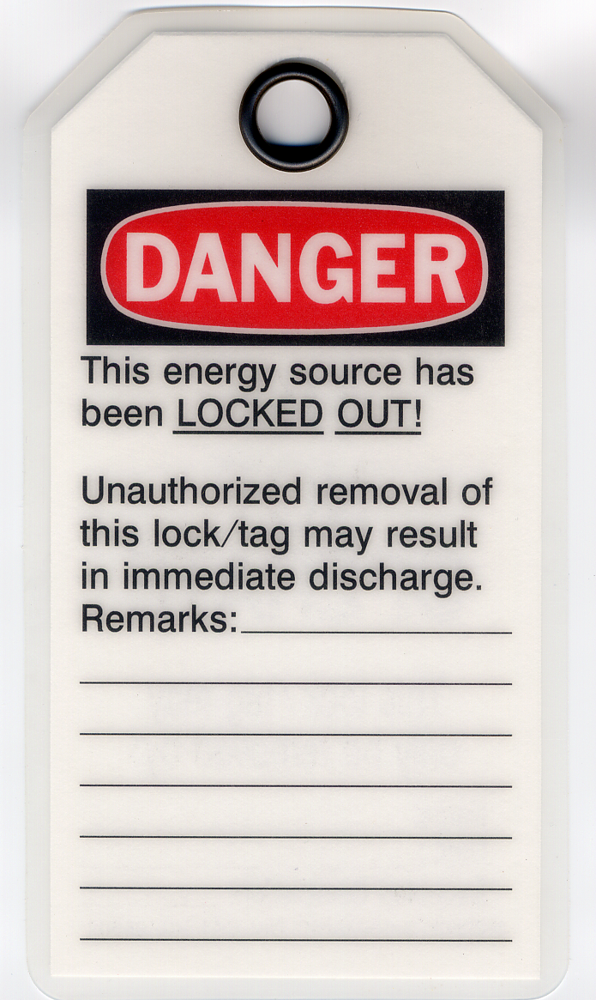
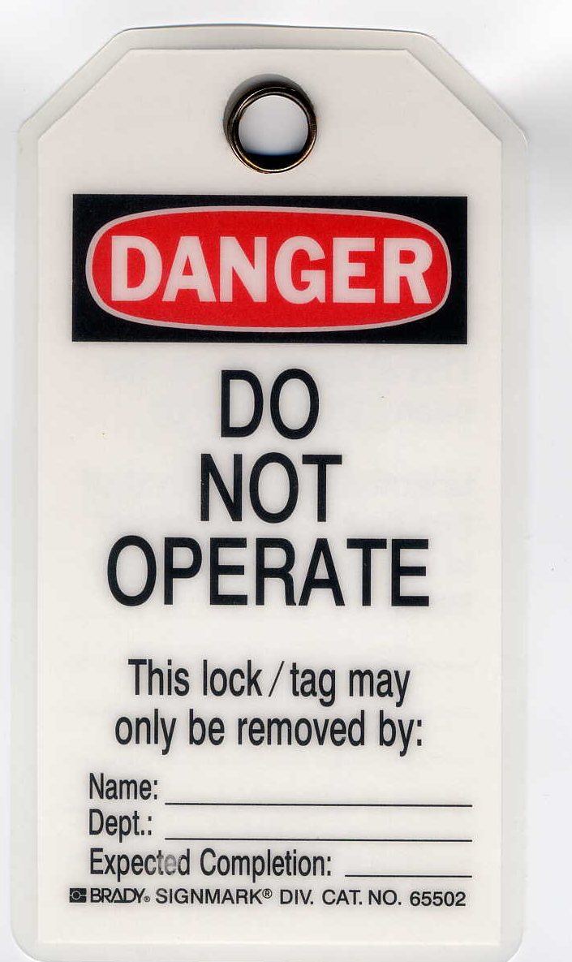
Back
Front

Lockout/Tagout Procedure Page 4 of 9

  - Equipment Shutdown:
Note: At the WTTP, Operations will perform all Lockout/Tagout operations as per Lockout/Tagout Permit.

At the pump stations Maintenance will perform all Lockout/Tagout operations as per Lockout/Tagout Permit.

    - Electrical Lock-Out / Tag-Out:
Note: Never pull an electrical disconnect /switch while the equipment is under load.

      - Shutdown the system at the local controls.
      - Isolate all energy sources by shutting off the source at the main feed.
      - Energy sources may include circuit breakers or disconnect switches, etc.
      - Never remove a fuse instead of disconnecting.
      - Use a meter on the load side of the switch to ensure the equipment has zero potential and is not back feed.
      - Try to start the equipment at the equipment control switch to ensure that all power is disconnected.
      - Leave the start switch in the off position after testing.
    - Mechanical Lock-Out / Tag-Out:
      - Shutdown the system at the local controls.
      - Isolate all energy sources by shutting down the source at the main feed.
      - Energy sources may include line valves, control valves, springs, gravity, etc.
      - Secure any equipment that could move due to spring pressure, gravity, hydraulic or pneumatic energy.
      - If blocks are used, ensure the blocks are strong enough and durable enough to prevent any movement of the equipment.
      - Open all drain valves to ensure all lines and equipment are depressurized.
      - Blank or blind a pipe line, flange or duct by applying a plate or cap over the end after ensuring it is depressurized.

Lockout/Tagout Procedure Page 5 of 9

Note: Only authorized personnel Shall apply Lockout/Tagout.
Note: Locks Must be: 1. Durable 2. Standardized 3. Strong 4. Identified Tags Must :be: 1. Securely attached to Lock and local controls. 2. Tags can not be inadvertently or accidentally detached during use.

  - Application of Lockout/Tagout devices:
    - Only Safety First Authority approved Lockout/Tagout devices and tags are to be used.
    - Lockout/Tagout devices Shall be any of the following:
      - Approved Locks.
      - Breaker Switch Lockouts.
      - Electrical Plug Lockouts.
      - Valve Handle Lockouts.
      - Chains with lock attached.
    - Apply approved locks or Lockout/Tagout devices to all main feeds of the equipment being worked on.
    - Apply a tag to the following:
      - Main feed.
      - Local control.
      - Inlet, discharge, drain and vent valves.
    - Every tag Will be filled out by the authorized person applying the Lockout.

Lockout/Tagout Procedure Page 6 of 9

    - Every tag will have the authorized person’s:
      - Name.
      - Department.
      - Time & Date the lockout was applied.
      - Equipment being worked on.
      - Expected completion date.
      - Any remarks that may be important to other individuals working on this equipment.
    - Every valve lockout tag Will be marked:
      - Do Not Open Valve (e.g. Inlet or discharge valve).
      - Do Not Close Valve (e.g. Vent valve or drain valve).

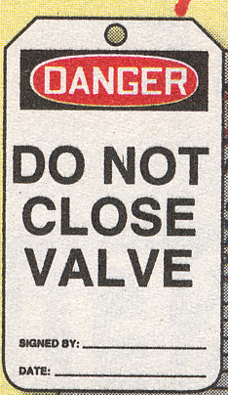


Inlet or discharge valve
Vent valve or drain valve

      - IF more then one person is working on the equipment at the same time each person must apply his/her own Lock & Tag.
      - Multiple lock hasps are used when more that one lock is to be applied to the same power source.

Lockout/Tagout Procedure Page 7 of 9

Note: The maintenance Forman will retain the permit until all maintenance work is completed.

All permits will be posted in the Forman’s office area.

When all maintenance work is completed the Lockout/Tagout Permit is turned over to Operations to have energy restored.

  - Control of Stored Energy & Equipment Isolation Verification.
    - Electrical:
      - Install ground wires where needed.
      - Use a meter on the load side of the switch to ensure the equipment has zero potential and is not back feed.
      - Try to start the equipment at the equipment control switch to ensure that all power is disconnected.
      - Leave the start switch in the off position after testing.
    - Mechanical:
      - Ensure all equipment parts have stopped moving.
      - Bleed lines and leave vent lines open.
      - Relieve trapped pressure.
      - Drain process piping systems and close valves to prevent flow of hazardous materials.
      - Block or brace equipment that could fall because of gravity.
      - Block any parts in a hydraulic or pneumatic that could move when pressure is released.
      - IF the line must be blocked and there is no valve, use a blank flange.
      - Try to start the equipment at the equipment control switch to ensure that all power is disconnected.
      - Leave the start switch in the off position after testing.
  - Removing Lockout/Tagout Devices
Note: When work is completed the permit will be turned over to Operations to insure all Lockout/Tagout devices and tags have been properly removed.

Lockout/Tagout Procedure Page 8 of 9

    - Ensure that the equipment is safe to operate.
    - Remove all tools from the work area.
    - Ensure the equipment is fully assembled.
    - Ensure all guards are in place.
    - Notify all personnel in the area that you are removing the Lockout/Tagout.
    - Each Lockout/Tagout device must be removed by the authorized person who applied the device.
    - Operations will forward all completed permits to the Safety / Training Coordinator for electronic filing.

Note: Exceptions

1. When the authorized person who applied the Lockout/Tagout is not available to remove it, the device may be removed under the direction of a Foreman.
2. Make all reasonable efforts to contact the authorized person to inform them that their lockout has been removed.
3. Two Man Rule - Locks may not be cut unless there is a Foreman present while cutting the lock.

  - Special Situations
    - All outside contractors must follow Safety First Authority’s Lockout/Tagout procedure.
    - IF the energy source is not capable of being locked out. - The Employer must be able to demonstrate that the utilization of a Tagout System will provide full employee protection.
    - IF you must temporarily re-energize the equipment you are working on use the following steps:
      - Remove all unnecessary tools from the work area.
      - Inform all personnel in the area that you are removing the Lockout/Tagout on the equipment.
      - Remove the Lockout/Tagout device.
      - Re-energize the equipment.
      - As soon as the energy is no longer needed, re-apply the Lockout/Tagout.

Lockout/Tagout Procedure Page 9 of 9

MATERIAL HANDLING AND STORAGE

- Where mechanical handling equipment is used, sufficient safe clearances shall be allowed for aisles, at loading docks, through doorways and where turns or passage must be made.

- Aisles and passageways shall be kept clear and in good repair with no obstruction across or in aisles that could create a hazard.

- Permanent aisles and passageways shall be appropriately marked.

- Storage of material shall not create a hazard. Bags, containers, bundles, etc. stored in tiers shall be stacked, blocked, interlocked and limited in height so that they are stable and secure against sliding or collapse.

- Storage areas shall be kept free from accumulation of materials that constitute hazards from tripping, fire, explosion, or pest harborage.

- Where necessary, proper drainage shall be provided.

- Clearance signs to warn of clearance limits shall be provided.

- Storage of items should not exceed a height of 21 feet. This does not include storage of items such as coal, select backfill, or other noncombustible bulk items.

- Storage of pipe lengths should always be done using proper chocking procedures.

- Never stockpile pipe to a height that cannot be handled easily by a backhoe or other means of unloading.

Material Handling and Storage Policy Page 1 of 1

USE OF SCBA FOR ON –CALL TRUCKS

Unit/Area of
Responsibility: Mechanical & Electrical On- Call trucks

Job Hazards: Poisonous gases & toxic gas created by fire

Protective
Equipment: SCBA (Self Contained Breathing Apprentice).

Purpose: Used for timely removal of personnel from a hazardous environment.

Note: SCBA face mask valves are constructed of very thin rubber material which must be pliable at all times in order to be operationally sound.
Mask face pieces should be warm prior to installation to ensure proper valve operation. Placing the mask in the cab before leaving for the job will allow the valves time to warm up.

PROCEDURE:
- On –Call SCBA Preparation.
  - Prior to responding to On- Call work.
    - Remove face mask from SCBA unit and place the mask in cab area to insure inhalation valves are warm.

Use of SCBA For On –Call Trucks Page 1 of 1
VEHICLE ACCIDENT PROCEDURE

- Employees must carry driver’s licenses at all times while driving Authority vehicles and road equipment and while driving personal vehicles on Authority business.

- All employees should familiarize themselves with the “Accident Packet” that is equipped in all vehicles.

- Accidents involving Authority vehicles and road equipment must be reported to the Police Department of the area in which the accident occurred via phone or Safety First Authority dispatcher (normal work hours), on-duty Shift Foreman during off hours.

- If there are no injuries to you, then use the disposable camera (equipped in the Accident Packet) to photograph vehicle positions, skid marks and witnesses, if any.

- Per PENN DOT, vehicles should not be moved from the accident scene unless authorized by a police officer.

- Never admit fault or liability to anyone (it will be handled by the insurance company).

- Limit discussion about the accident to immediate facts and obtain other parties information, driver’s license number, insurance information, auto registration and tag number.

- Use “Accident Packet” contents to diagram requested information.

- Attach the following to the diagram:

  - List of Witnesses
  - Weather Conditions
  - Posted Speed Limit
  - Any other pertinent facts to the accident.

- In the event of a fuel, hydraulic-oil spill, do not move the vehicle. Try to contain the spill as much as possible and contact Safety First Authority officials for assistance if needed.

- Report to your supervisor immediately. All accident information should be forwarded to the Administrative Point Person at the main office.

REMEMBER
STAY CALM & PROFESSIONAL
YOU ARE REPRESENTING THE AUTHORITY

Vehicle Accident Procedure Page 1 of 1
Reference information that can be reviewed for additional information includes:

- Safety & Health reference publications
- Government Publications & Standards
- Training Material
- Safety & Health Professional Organizations
1. Western, Central, & Eastern Sections
2. Pennsylvania Water Environment Association
3. Water Environment Federation
4. American Water Works Association
5. The American Society for Safety Engineers (ASSE)
6. The American Industrial Hygiene Association
7. The National Safety Council

Websites
- Federal OSHA @ www.OSHA.gov
- Federal EPA @ www.epa.gov
- The Center for Disease Control (CDC) @ www.cdc.gov
- The National Institute for Occupational Safety & Health @ www.cdc/niosh.gov

