With summer upon us, mowing grass, gardening and fertilizing seem to be on the top of everyone’s “To Do List”. But even these common activities can be harmful to the environment. One of the most important things we can do is prevent pollution by properly using and disposing of yard waste and pesticides.

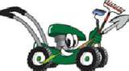
Properly Dispose of Yard Waste
Yard and grass clippings can reach our local waterways by washing into storm drains. Keep green waste out of storm drains by grasscycling or composting. Grasscycling is the practice of leaving clippings on the lawn when mowing. The clippings quickly decompose, returning nutrients to the soil. It makes caring for your lawn easier, will not cause thatch and reduces the lawn’s water loss and need for fertilizer.
To grasscycle, it is best to cut grass when the surface is dry (no drops of moisture on the grass), and to keep mower blades sharp. Follow the “1/3 rule”: Mow the lawn often enough so that no more than 1/3 of the length of the grass blade is removed in any one mowing. Proper mowing will produce short clippings that will not cover up the grass surface. You may have to cut the lawn more frequently, or double cut, when the lawn is growing quickly.
Backyard composting is the process of allowing nature to break down your green waste. When you mix your grass clippings, weeds, trimmings and water in a bin, beneficial insects and microorganisms decompose the mixture into finished compost. You may have finished compost in as early as six weeks which can be placed over the soil as mulch, or mixed into the soil as a wonderful soil amendment.

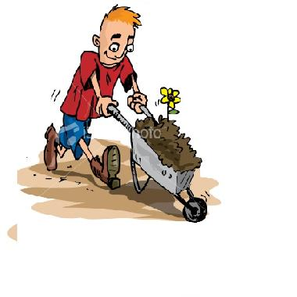
Properly Dispose of Fertilizers
Did you know that fertilizers can harm our environment? Fertilizers promote algae growth in our waterways. When algae decomposes, the oxygen level in the water is depleted, harming aquatic life. When using fertilizers, follow application instructions, avoid overwatering and do not apply if rain is forecasted.
If that bag of fertilizer you purchased remains unused at the end of the season, you can always store it according to manufacturer’s directions until you need it next – or better yet, share it with a neighbor whose lawn needs a little TLC. In some cases, disposal is in order, but it can be tricky due to its hazardous nature. You should be careful not to toss fertilizer in the trash or to wash it down the drain, because the contents will contaminate the water supply. The best option for disposing of fertilizers is at your local household hazardous waste (HHW) facility. Drop-off locations can also be found on www.earth911.com.

